

# “BUILD AN EVENT MANAGEMENT SYSTEM”

# 

**NAAN MUDHALVAN PROJECT REPORT**

***Submitted by***

**SOWMIYAA S (620120104096)**

**SOWNDHARYA P (620120104097)**

**PRIYADHARSHINI R (620120104312)**

**SRI SWETHA DEVI M (620120104314)**

**VIDHYA SRI R (620120104318)**

***in partial fulfilment for the award of the degree of***

# Bachelor of Engineering

***in***

# Computer Science and Engineering

**AVS Engineering College,**

**SALEM – 636003.**

# ANNA UNIVERSITY::CHENNAI 600025

**BONAFIDE CERTIFICATE**

## Certified that this the project report titled “BUILD AN EVENT MANAGEMENT SYSTEM” is the bonafide work of “SOWNDHARYA S (620120104067), SOWMIYAA P (620120104069), PRIYADHARSHINI (620120104312), SRI SWETHA DEVI M (620120104314), VIDHYA SRI R (620120104318)” who carried out the project work under my supervision.

|  |  |
| --- | --- |
| **SIGNATURE**  **Prof. S. DHAMODARAN M.E.,**  **ASSISTANT PROFESSOR**  **FACULTY MENTOR**  Department of CSE,  AVS Engineering College, Salem-636003. | **SIGNATURE**  **Dr.R.VISHWANATHAN M.E., Ph.D.,**  **ASSISTANT PROFESSOR**  **SPOC FACULTY**  Department of CSE,  AVS Engineering College, Salem-636003. |
|  |  |

## SPOC HEAD OF THE DEPARTMENT

### **ACKNOWLEDGEMENT**

I thank my god for providing me with everything that I required in completing

this project successfully.

My most sincere salutations go to ANNA UNIVERSITY that gave me an

opportunity to have sound base of Computer Science and Engineering.

I acknowledge with deep sense of gratitude to our Chairman

#### Shri.K.KAILASAM, secretary Mr.K.RAJAVINAYAKAM M.B.A., and our Correspondent

#### Mr.K.SENTHIL KUMAR B.Tech., for providing all the necessary

facilities to do this project.

I thank our Vice Principal’s **Dr.R.VISHWANATHAN M.E., Ph.D.,** and

**Dr.D.R.JOSHUA M.E., Ph.D.,** for his timely advice and encouragement.

I offer my sincere thanks to **Dr.M.VILASHINI M.E., Ph.D.,** Dean and **Prof .V.MEENA M.E.,** Head of The Department, for giving his constant support and motivation.

I am indebted to my guide **Prof. S. DHAMODARAN M.E.,** Assistant

professor for my constant guidance and encouragement throughout the project work. I Also express my thanks to all faculty members and friends for their support towards the successful; completion of the project.

**TABLE OF CONTENTS**

|  |  |  |  |
| --- | --- | --- | --- |
| **Chapter No** | **Title** | | **Page No** |
| **1.** | LIST OF FIGURESLIST OF ABBREVIATIONSPROJECT SPECIFICATIONProject Goal  * 1. Project Scope   2. Problem Statement Definition   3. Empathy Map Canvas   4. Ideation & Brainstorming   5. Proposed Solution   6. Functional & Technical Requirements   7. Project Road Map   1.8.1 DATA FLOW DIAGRAM  1.8.2 TECHNICAL ARCHITECTURE | **5**  **6**  **7**  **8**  **9**  **10**  **11**  **12**  **13**  **14**  **15**  **19**  **19**  **20** | |
| **2.** | **PREPARATION DATA MODELING**  2.1 Salesforce Developer Org  2.2 Custom Object Creation & Tabs  2.3 Lightning App | | **24**  **24**    **25**  **29** |
| **3.** | **USERS AND DATA SECURITY** | | **31** |
|  | 3.1 User  3.2 Permission Sets  3.3 Profile | | **31**  **32**  **34** |
| **4.** | **AUTOMATION**  4.1 Approval process | | **36**  **36** |
| **5.**  **6.**  **7.** | **REPORTS AND DASHBOARDS**  5.1 Reports  5.2 Dashboards  5.3 User Adoption  **CONCLUSION**  **PROJECT DEMONSTRATION**  **GITHUB, DEMO LINK & TRAILHEAD LINKS** | | **38**  **38**  **40**  **42**  **44**  **45** |

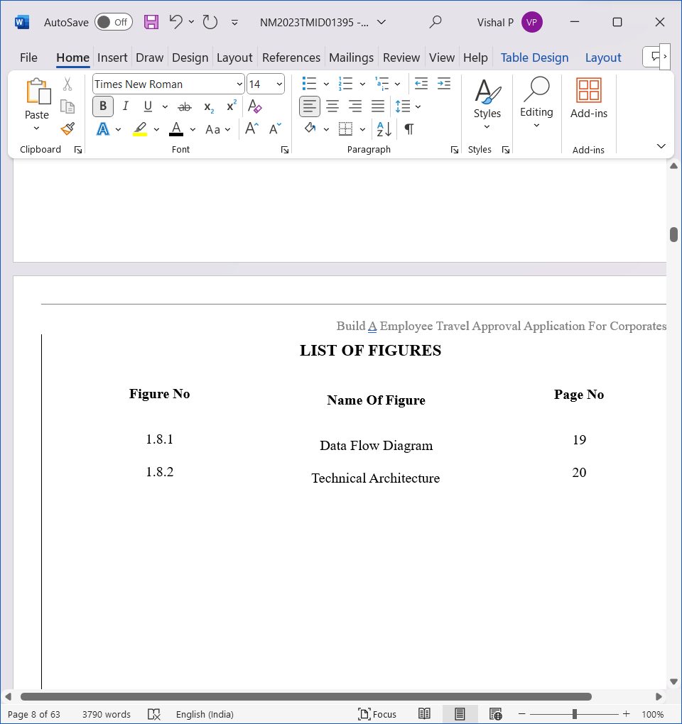

|  |
| --- |
|  |
|  |
| LIST OF ABBREVIATIONSEMS Event Management SystemCRM Customer Relationship ManagementCMS Content Management SystemAPI Application Programming InterfaceUX User ExperienceUI User InterfaceDBMS Database Management SystemERP Enterprise Resource PlanningCMS Event Content Management SystemSaaS Software as a ServicePMS Project Management SystemROI Return on InvestmentKPI Key Performance IndicatorAPI Application Programming InterfacePOS Point of Sale | |  |  |

# 

# CHAPTER-1

# PROJECT SPECIFICATION

# Project Goal

# 

# The goal for building an event management system can vary depending on the specific needs and objectives of the project, but here are some common goals and objectives for such a system. The primary goal of an event management system is to streamline the process of planning and organizing events. This includes managing tasks such as scheduling, venue selection, budgeting, and logistics. Create a centralized platform where all relevant event information is stored and easily accessible. This includes details about venues, vendors, participants, schedules, and budgets. Improve communication among event organizers, team members, and participants. An effective event management system should facilitate real-time communication through features like messaging, notifications, and updates. Provide a platform for event attendees to register, purchase tickets, and manage their participation in the event. This goal includes handling ticket sales, registration forms, and attendee management.

# Support marketing efforts by integrating tools for promoting events, tracking marketing campaigns, and collecting feedback from attendees. Efficiently manage and allocate resources such as staff, equipment, and materials required for the event. This ensures that resources are used effectively and without waste. Monitor event budgets, expenses, and revenue. The system should help in tracking financial transactions, managing invoices, and generating financial reports. Collect data on event performance, such as attendance, revenue, and participant feedback. This data can be used to make informed decisions and improve future events. Ensure that the system can handle events of various sizes and complexities, from small meetings to large conferences or festivals.

# 

* 1. **PROJECT SCOPE**

The project aims to develop and implement an Event Management System (EMS) to streamline the planning, execution, and management of events for [Your Organization Name]. The EMS will serve as a comprehensive tool for managing various types of events, from small meetings to large-scale conferences and festivals. Create a user-friendly, centralized platform to manage all aspects of event planning and execution. Streamline communication and collaboration among event organizers, team members, and participants. Facilitate event registration, ticketing, and attendee management. Enhance marketing and promotional efforts for events. Efficiently manage event resources, budgets, and financial transaction. Collect and analyze data to make informed decisions and improve future events User registration and authentication for event organizers and attendees. Event creation and management, including event details, dates, locations, and descriptions.

Event scheduling and calendar management. Ticketing and registration functionality. Attendee management, including check-in, badges, and participant information. Vendor and resource management. Budget and financial management, including invoicing and payment processing. Marketing and promotional tools, such as email campaigns and social media integration. Reporting and analytics features. Integration with third-party tools (e.g., CRM, payment gateways, and marketing platforms). Hardware procurement and installation.Mobile application development (initially, but may be considered in future phases). Customization for non-standard or highly specialized event types. Physical event logistics, such as catering and on-site management (beyond resource management). Legal and regulatory compliance beyond data protection and privacy. Ongoing system maintenance and support post-implementation.

* 1. **PROBLEM DEFINITION**

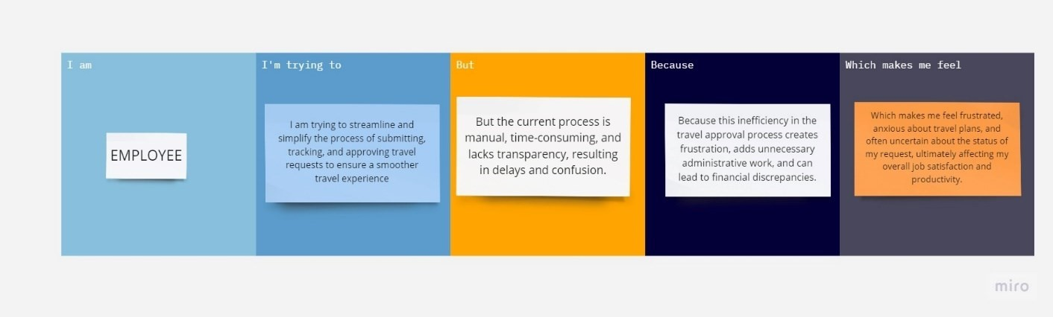

|  |  |  |  |  |  |
| --- | --- | --- | --- | --- | --- |
| **Problem**  **Statement**  **(PS)** | **I am**  **(Employee)** | **I’m trying to** | **But** | **Because** | **Which makes me feel** |
| PS | Employee | I am trying to streamline and simplify the process of submitting, tracking, and approving travel requests to ensure a smoother travel experience | But the current process is manual, timeconsuming, and lacks transparency , resulting in delays and confusion. | Because this inefficiency in the travel approval process creates frustration, adds unnecessary administrative work, and can lead to financial discrepancies | Which makes me feel frustrated, anxious about travel plans, and often uncertain about the status of my request, ultimately affecting my overall job satisfaction and productivity |

* 1. **EMPATHY MAP CANVAS**

An empathy map is a simple, easy-to-digest visual that captures knowledge about a user’s behavior and attitudes.

It is a useful tool to helps teams better understand their users. Creating an effective solution requires understanding the true problem and the person who is experiencing it. The exercise of creating the map helps participants consider things from the user’s perspective along with his or her goals and challenges.

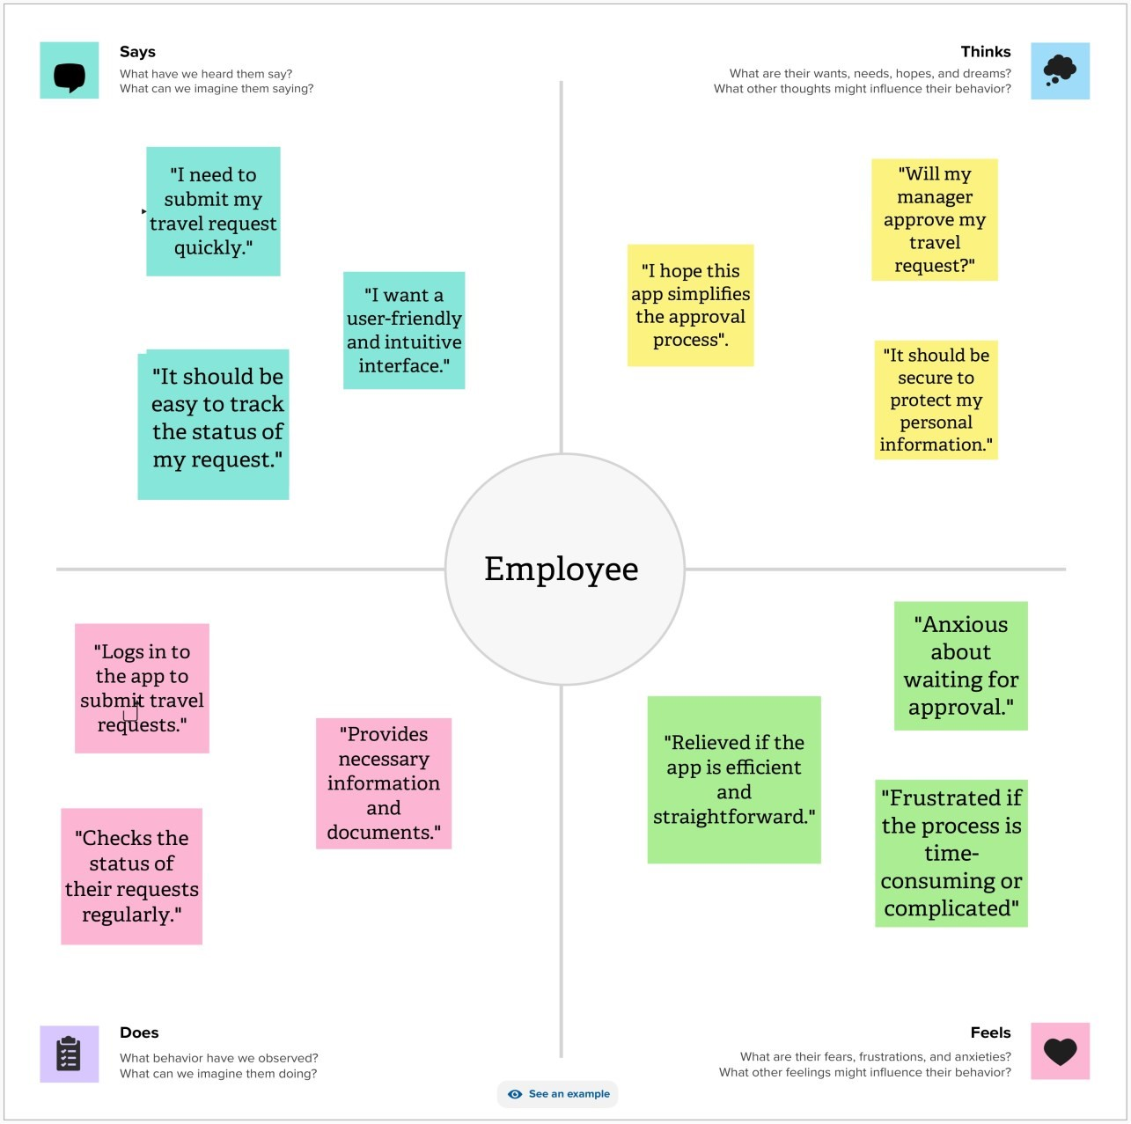

* 1. **IDEATION & BRAINSTORMING**

Brainstorming provides a free and open environment that encourages everyone within a team to participate in the creative thinking process that leads to problem solving. Prioritizing volume over value, out-of-the-box ideas are welcome and built upon, and all participants are encouraged to collaborate, helping each other develop a rich amount of creative solutions.

**Step-1: Team Gathering, Collaboration and Select the Problem Statement:**

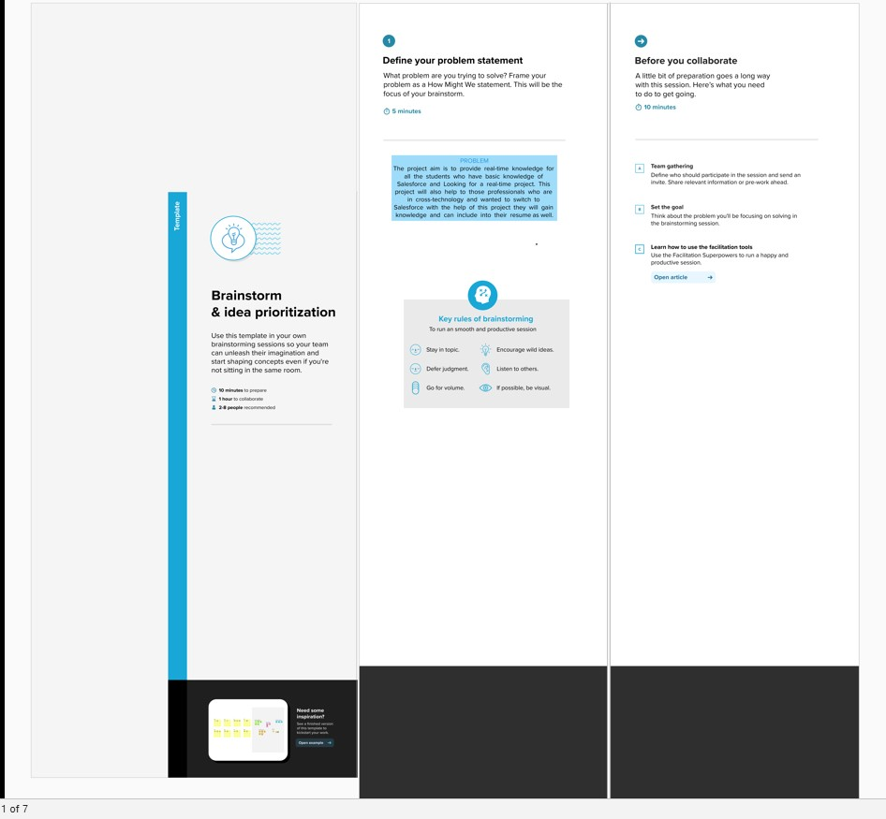

**Step-2: Brainstorm, Idea Listing and Grouping:**

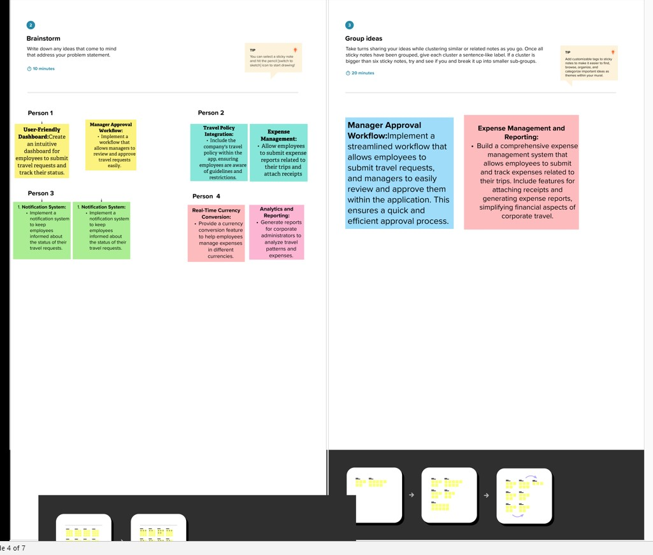

**Step-3: Idea Prioritization:**

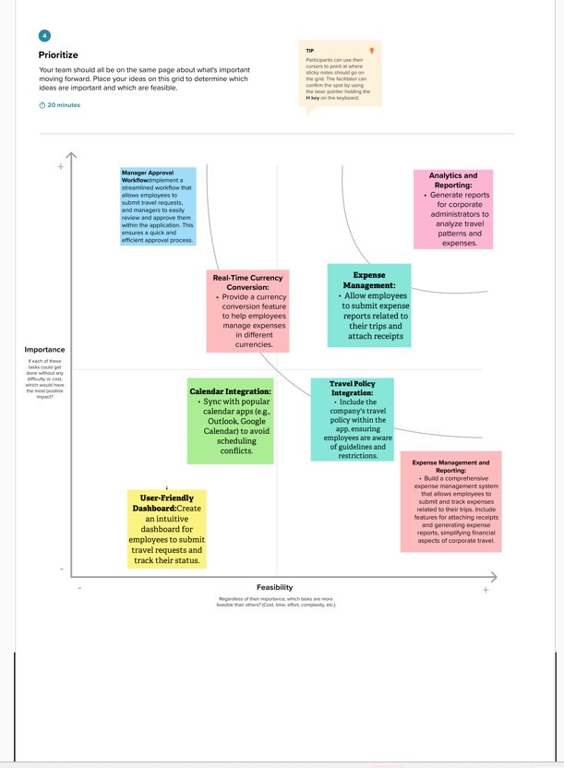

* 1. **PROPOSED SOLUTION**

|  |  |  |
| --- | --- | --- |
| **S. No** | **Parameter** | **Description** |
| 1. | Problem Statement (Problem to be solved) | Organizing and managing events within [Your Organization Name] has become a complex and time-consuming task. The absence of a comprehensive Event Management System (EMS) has resulted in several operational challenges and inefficiencies, hindering the successful execution of various events, from small meetings to large-scale conferences and festival |
| 2. | Idea / Solution description | To address the challenges outlined in the problem statement and provide a comprehensive solution for building an Event Management System (EMS), the system will incorporate several key components and features. Firstly, it will create a user-friendly dashboard for event organizers, offering collaborative tools and a shared calendar to streamline event planning and task coordination. Additionally, the system will feature an integrated registration and ticketing module, ensuring secure participant data management while offering a mobile-friendly participant portal for easy access and engagement. |

|  |  |  |
| --- | --- | --- |
| 3. | Novelty / Uniqueness | To create a truly novel and unique Event Management System (EMS), consider incorporating cutting-edge features and concepts that set your system apart from existing solutions. One innovative approach is to employ AI-powered event recommendations, utilizing artificial intelligence to analyze attendee preferences and provide personalized event suggestions. Augmented Reality (AR) and Virtual Reality (VR) integration can elevate the event experience, allowing attendees to virtually explore venues or participate in immersive activities from anywhere |
| 4. | Social Impact / Customer  Satisfaction | Building an Event Management System (EMS) not only offers operational efficiency and convenience but also has a substantial social impact and the potential to greatly enhance customer satisfaction. By streamlining the event planning process, the EMS reduces the administrative burden on event organizers, allowing them to allocate more time and resources toward creating meaningful and engaging events. This, in turn, benefits event participants who experience smoother registration, ticketing, and overall event interactions. |

* 1. **FUNCTIONAL & TECHNICAL REQUIREMENTS**
     1. **FUNCTIONAL REQUIREMENTS**

|  |  |  |  |
| --- | --- | --- | --- |
| **FR**  **No.** | **Functional Requirement**  **(Epic)** | **Description** | |
| FR-1 | USER REGISTRATION | Allow users to create accounts, including organizers, participants, and admin roles. | |
| FR-2 | USER AUTHENTICATION | Implement secure login mechanisms, such as username/password and two-factor authentication. | |
| FR-3 | EVENT CREATION | Enable event organizers to create new events, including event details, dates, and descriptions. | |
| FR-4 | EVENT SCHEDULING | Provide a calendar for scheduling events, sessions, and related tasks with notifications. | |
| FR-5 | REGISTRATION & TICKETING | Develop a module for attendee registration, ticketing, payment processing, and confirmation. |  |
| FR-6 | ATTENDEE MANAGEMENT | Facilitate attendee check-in, badge generation, and the management of participant information. | |
| FR-7 | VENDOR & RESOURCE | Offer tools for managing vendors, resources, staff, equipment, and materials for events. | |
| FR-8 | BUDGET MANAGEMENT | Create budgeting features, including tracking expenses, generating invoices, and payment processing. | |
| FR-9 | MARKETING & PROMOTION | Integrate marketing tools for email campaigns, social media sharing, and tracking campaign performance. | |
| FR-10 | REPORTING & ANALYTICS | Develop reporting features to collect data on event performance, attendance, revenue, and participant feedback. | |
| FR-11 | INTEGRATION | Allow integration with other software systems and platforms, such as CRM, payment gateways, and marketing tools. | |
| FR-12 | CUSTOMIZATION | Offer customization options to adapt the system to various event types and organization needs. | |

* + 1. **TECHNICAL REQUIREMENTS**

|  |  |  |
| --- | --- | --- |
| **TR**  **No.** | **Technical Requirement** | **Description** |
| TR-1 | Technology Stack | Define the technology stack, including programming languages, frameworks, and databases. |
| TR-2 | Hosting and Deployment | Specify the hosting environment (e.g., cloud, on-premises) and deployment procedures. |
| TR-3 | Scalability | Ensure the system can scale horizontally to accommodate varying levels of traffic and events. |
| TR-4 | Security | Implement security protocols, including data encryption, firewalls, and secure APIs to protect sensitive information. |
| TR-5 | Data Backup and Recovery | Set up automated data backup and recovery processes to prevent data loss. |
| TR-6 | Performance Optimization | Optimize system performance to ensure fast response times and efficient resource utilization. |
| TR-7 | Integration | Define standards for integrating with third-party services, systems, and APIs. |
| TR-9 | Mobile Responsiveness | Ensure the EMS is mobile-friendly and responsive for users on various devices. |
| TR-10 | Data Storage and Management | Create a robust database structure for efficient data storage, retrieval, and management. |
| TR-11 | Content Delivery | Employ Content Delivery Networks (CDNs) to enhance content delivery and reduce latency. |
| TR-12 | User Authentication | Implement secure user authentication mechanisms, including password hashing and token-based authentication. |
| TR-13 | Accessibility | Compliance Ensure the system complies with accessibility standards (e.g., WCAG) for users with disabilities. |

* 1. **PROJECT ROAD MAP**

* + 1. **DATA FLOW DIAGRAM**

A Data Flow Diagram (DFD) is a traditional visual representation of the information flows within a system. A neat and clear DFD can depict the right amount of the system requirement graphically. It shows how data enters and leaves the system, what changes the information, and where data is stored.

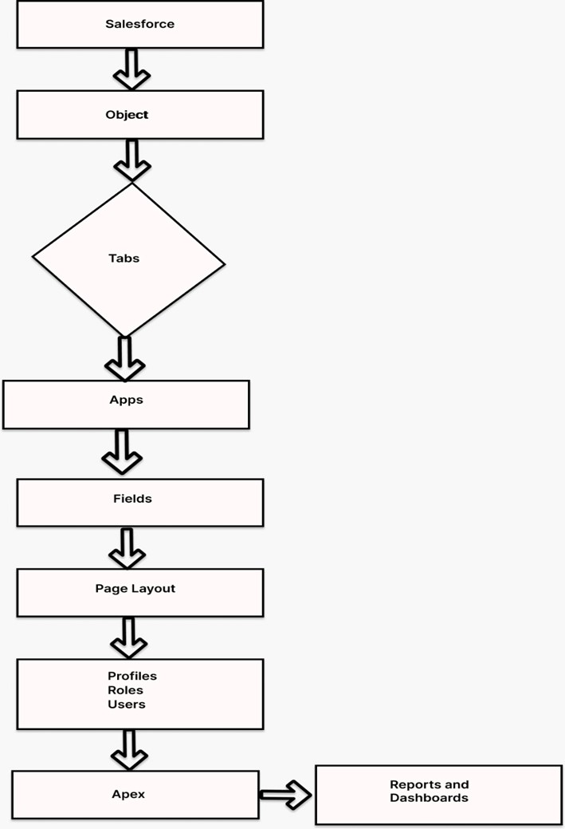

* + 1. **TECHNICAL ARCHITECTURE**

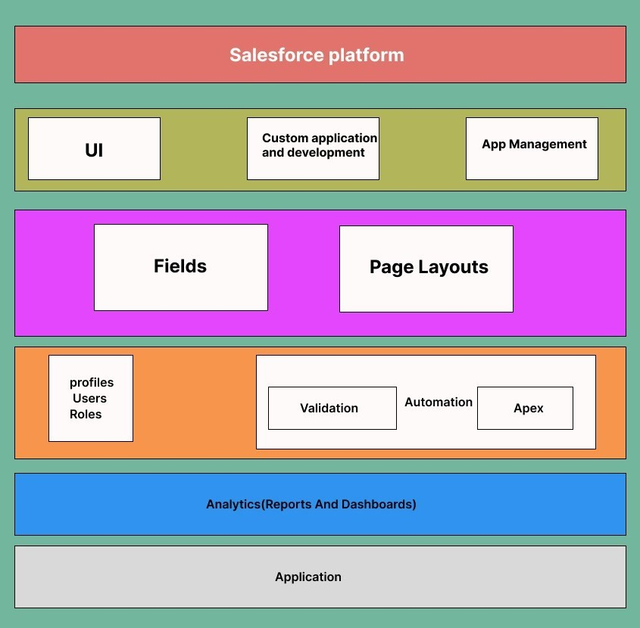

**TABLE-1: COMPONENT AND TECHNOLOGIES**

|  |  |  |  |
| --- | --- | --- | --- |
| **S.No** | **Component** | **Description** | **Technology** |
| 1. | User Interface | **Lightning Components**: Use Salesforce Lightning components to design the user interface for employees, managers, and administrators.  **Custom Pages:** Create custom Visualforce pages for more tailored and complex UI elements | Salesforce |
| 2**.** | Data Model | **Custom Objects:** Define custom objects in Salesforce to represent entities like travel requests, expenses, and approvals.  **Master-Detail and Lookup**  **Relationships:** Establish relationships between objects to maintain data integrity.  Custom Fields: Create custom fields to capture specific information, such as travel dates, expenses, and approval status. | Salesforce |
| 3. | Workflow  Automation | **Approval Processes:** Implement Salesforce Approval Processes to automate and streamline the travel request approval workflow.  **Process Builder and Flows:** Use Process Builder and Flows to automate routine tasks and send notifications. | Salesforce |
| 4. | Reporting and Analytics | **Custom Reports:** Create custom  reports to track travel request status, expenses, and other relevant metrics. | Salesforce |
| 5. | Security | **Role-Based Access Control (RBAC):** Configure RBAC to control who can access and modify data.  **Data Encryption:** Encrypt sensitive data both in transit and at rest.  **Audit Trails:** Maintain audit trails to log user activities for security and compliance purposes. | Salesforce |
| 6. | Salesforce  Development | **Apex:** Use Salesforce's proprietary programming language, Apex, for server-side logic and data manipulation.  **Visualforce:** Develop custom user interfaces with Visualforce pages and components.  **Lightning Web Components:** Create modern, component-based UIs using Lightning Web Components for a more responsive and dynamic user experience | Salesforce |

**TABLE-2: APPLICATION CHARACTERISTICS:**

|  |  |  |  |
| --- | --- | --- | --- |
| **S. No** | **Characteristics** | **Description** | **Technology** |
| 1. | Responsive  Design | Implement responsive design to adapt to various screen sizes, ensuring a consistent and visually pleasing user experience. | salesforce |
| 2**.** | Accessibility | Ensure that the application is accessible via multiple devices and browsers, catering to users on desktops, tablets, and mobile devices. This accessibility is crucial for users who need to make or approve travel requests while on the go. | salesforce |
| 3. | Userfriendly | The application should have an intuitive and user-friendly interface to make it easy for employees, managers, and administrators to navigate and use the system without extensive training. | Salesforce |
| 4. | Scalability | The application should be able to scale with the growing number of users and data, accommodating increasing demands without significant performance degradation. | salesforce |
| 5. | Performance | Ensure the application's performance meets or exceeds user expectations, with rapid response times for actions such as submitting requests or generating reports. | salesforce |
| 6. | Reporting and  Analytics | Enable users to generate custom reports and access analytics tools to gain insights into travel patterns, expenses, and approval efficiency. | salesforce |

**CHAPTER-2**

## PREPARATION DATA MODELING

### **2.1 Salesforce Developer Org**

In Salesforce, a Developer Sign Up or Developer Edition is a special type of Salesforce environment that is primarily used for development, testing, and learning purposes.

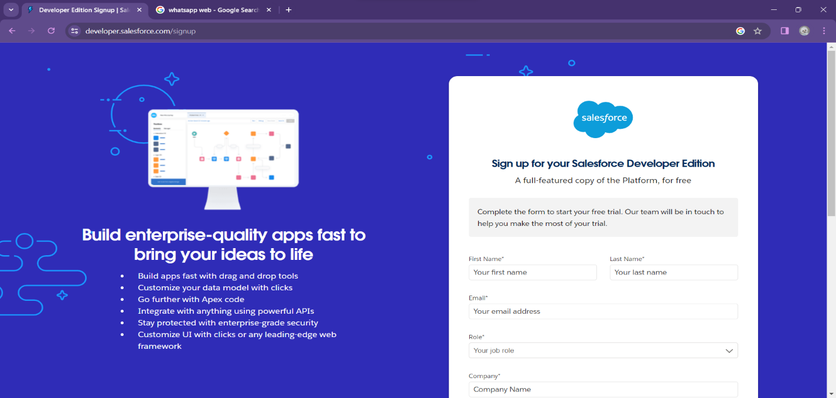

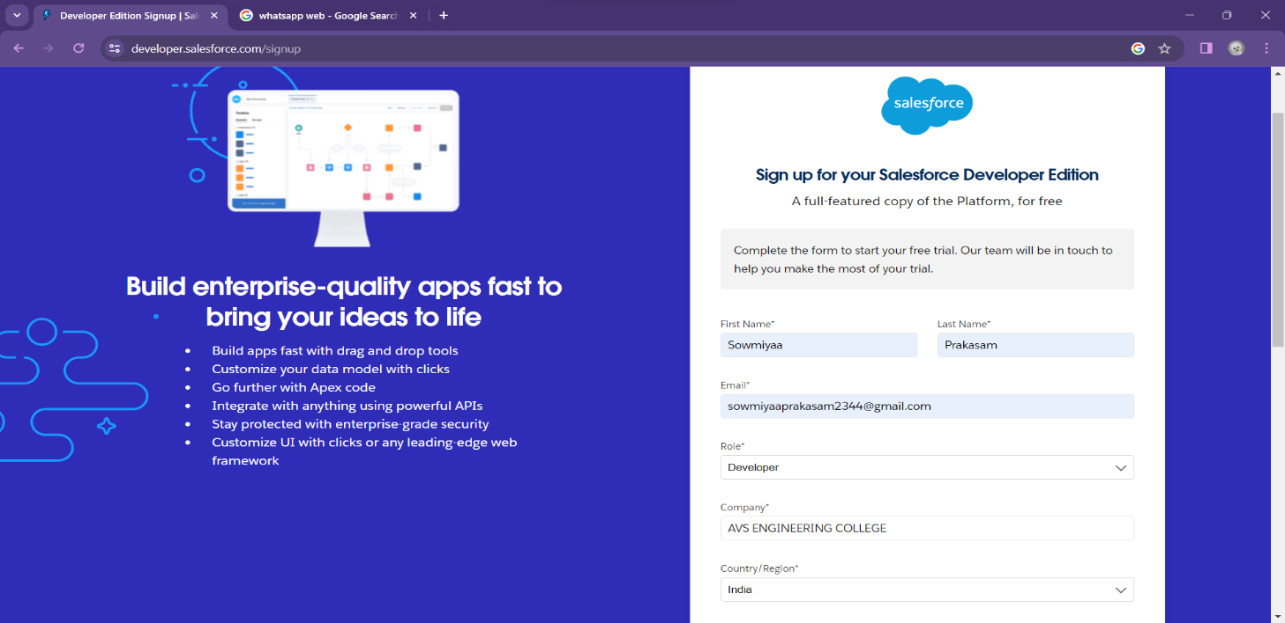

**Account Activation**

Activation tracks information about devices from which users have verified their

identity.

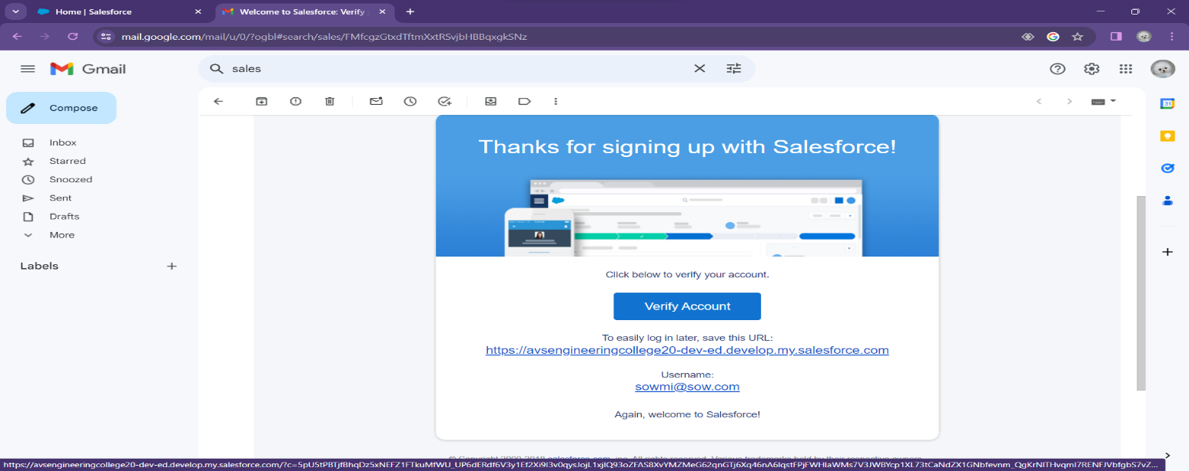

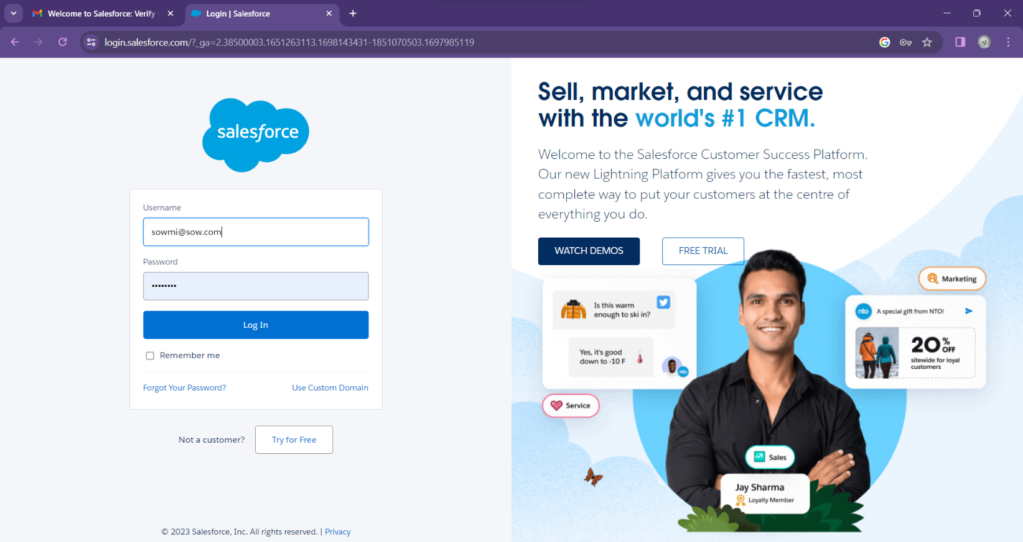

### **2.2 Custom Object Creation & Tabs**

**Custom Object Creation**

Objects are containers for your information, but they also give you special functionality.

Custom objects are create to store information that’s specific to your company or industry.

Custom objects in EVENT MANAGEMENT APP:

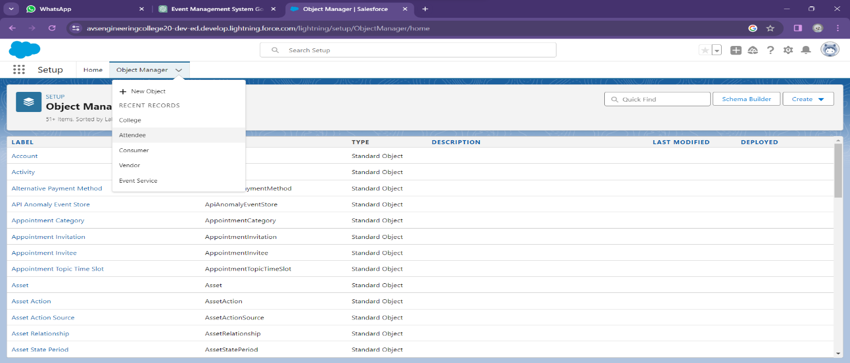

**FIELDS IN OCCASION OBJECT**

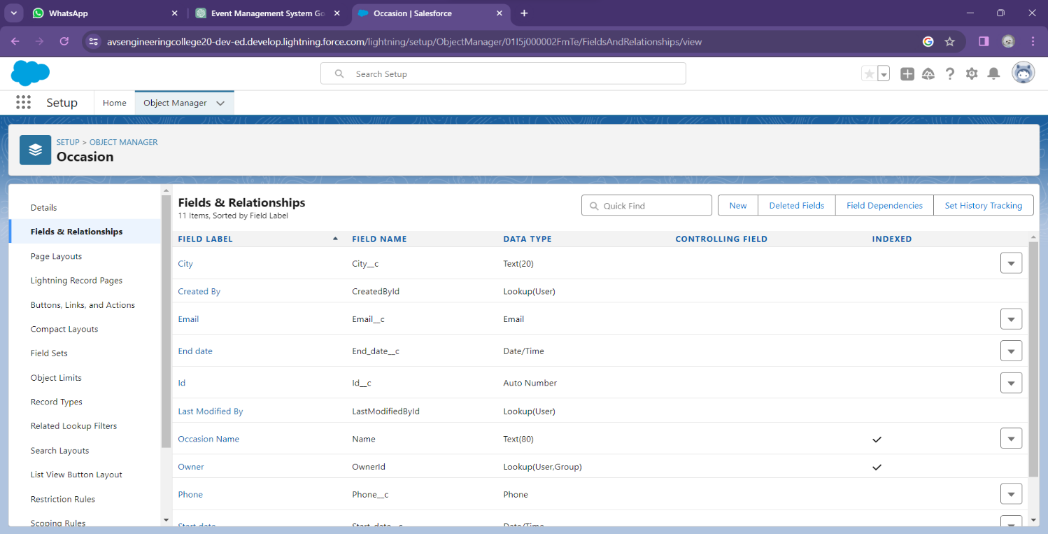

**FIELDS IN VENDOR OBJECT**

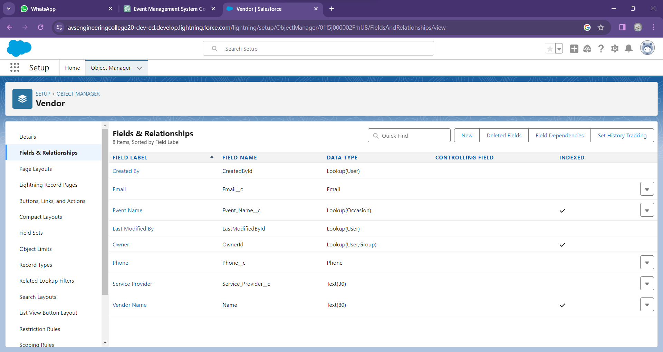

**FIELDS IN SPEAKER OBJECT**

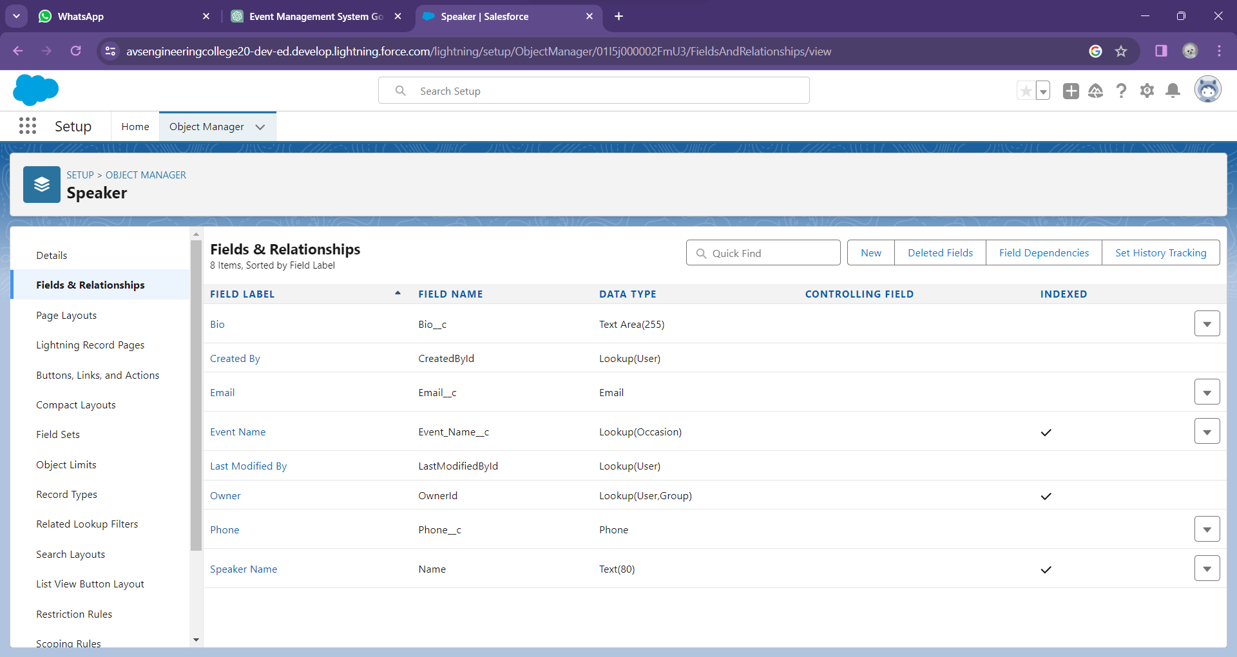

**FIELDS IN ATTENDEE OBJECT**

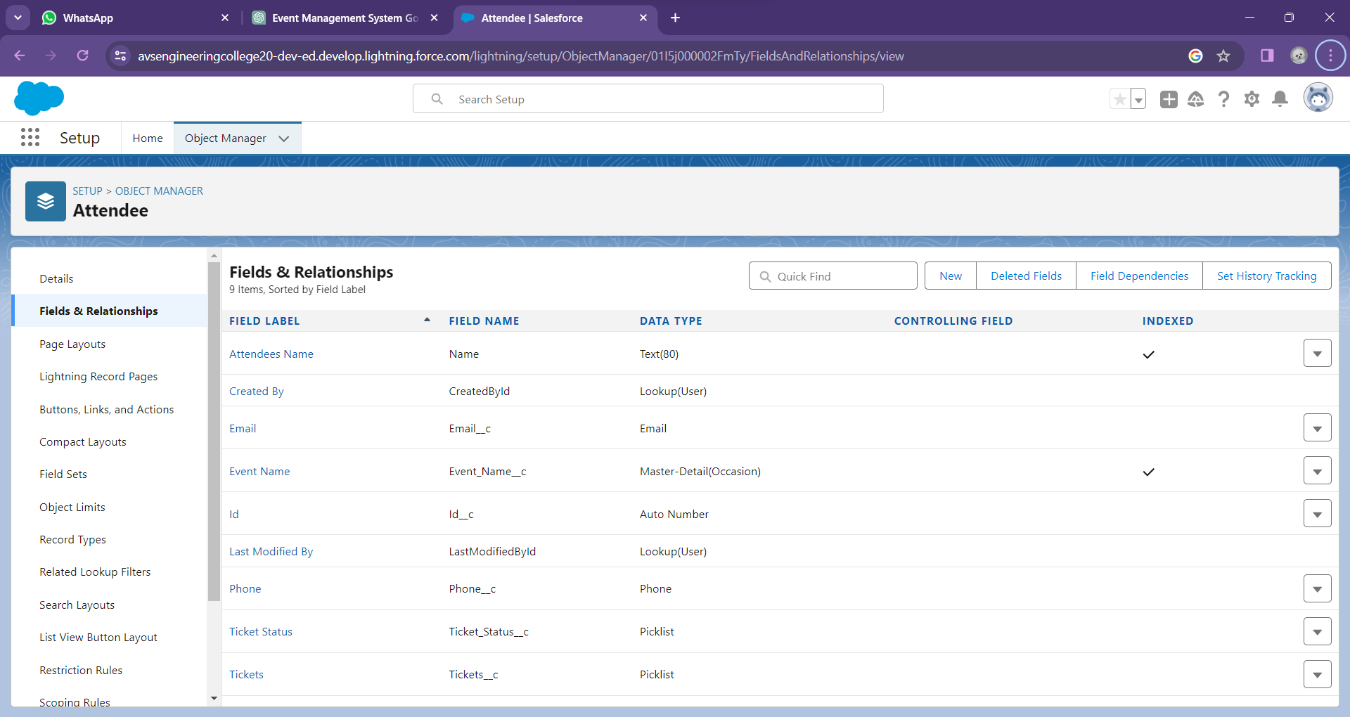

**FIELDS IN EVENT SERVICE OBJECT**

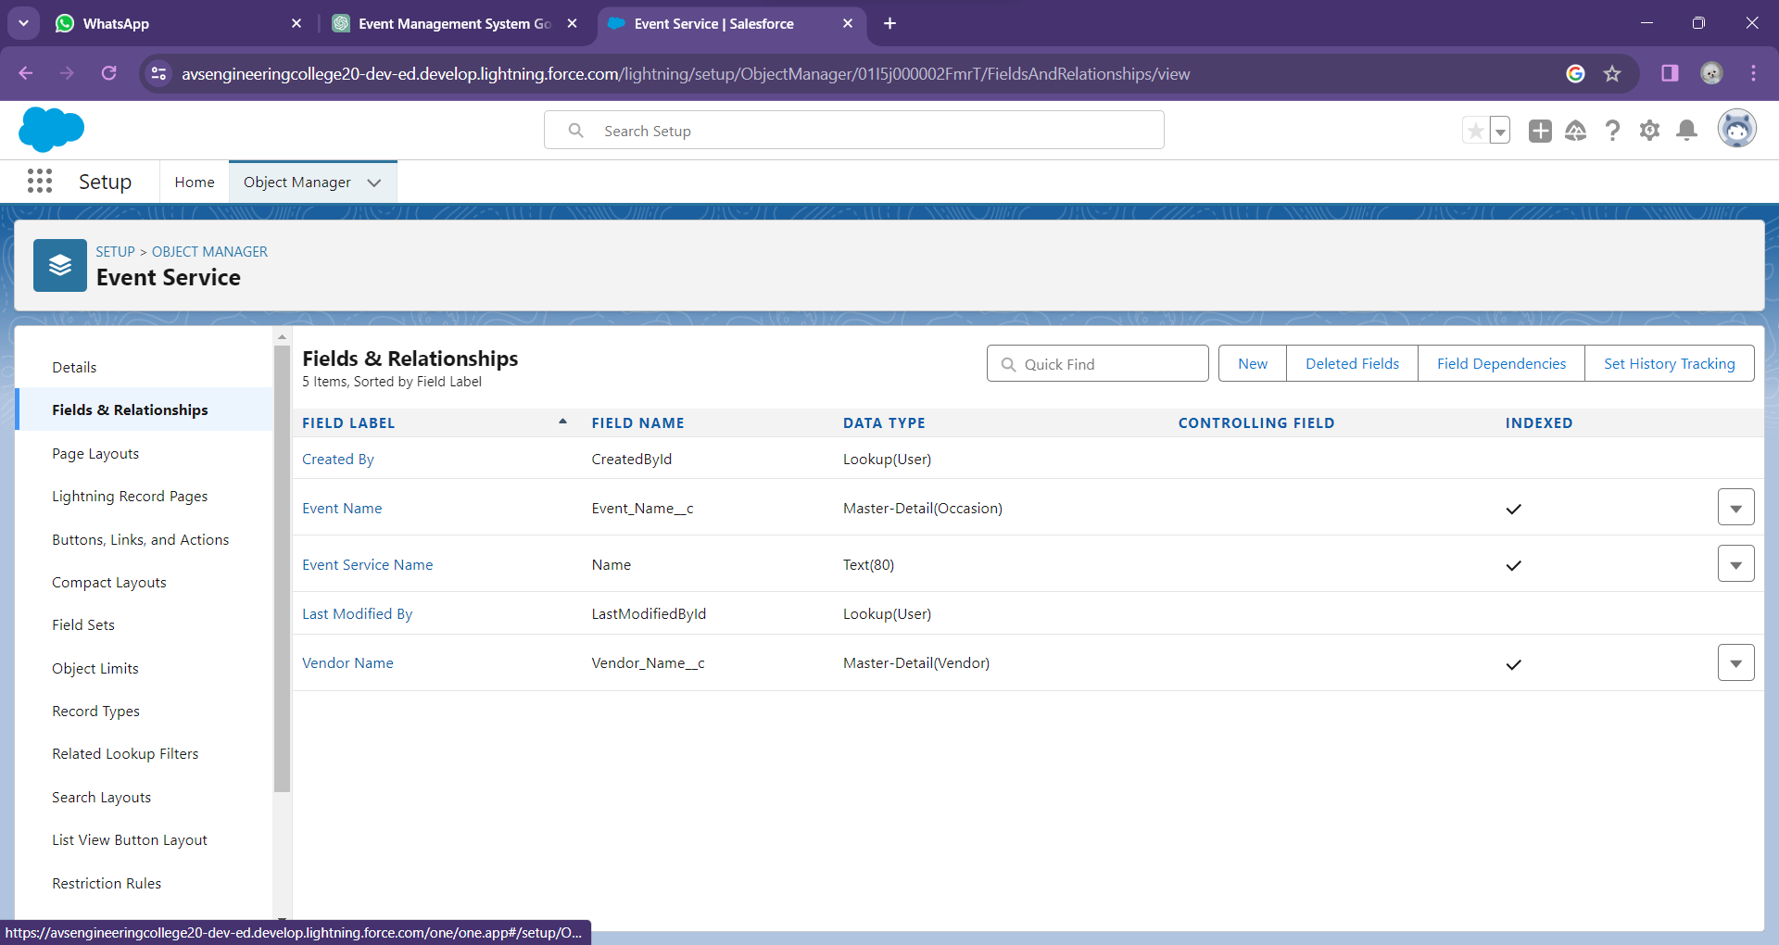

#### **Tabs**

Salesforce Tabs are like the menu options in a software application. They allow you to access specific functions, objects, or data.

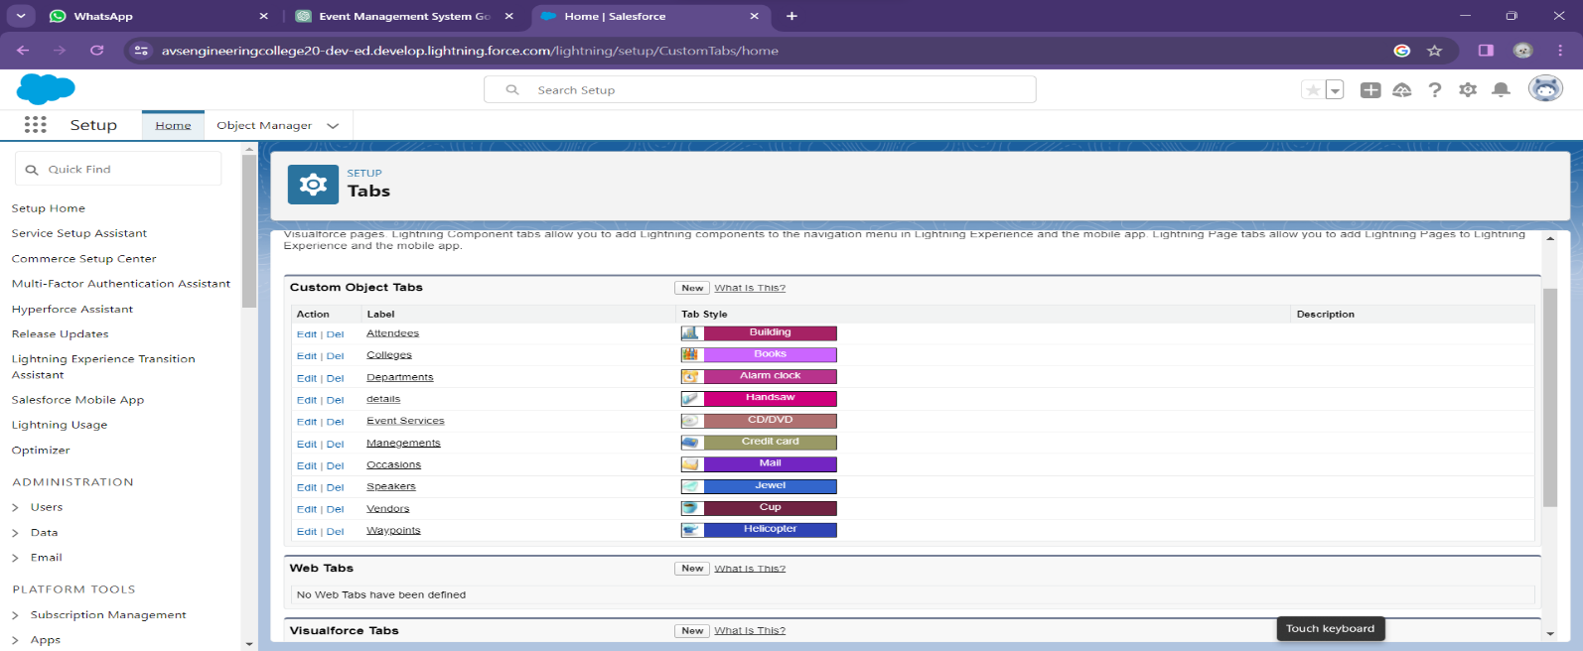

### **2.3 Lightning App**

The Lightning App Builder is a point-and-click tool that makes it easy to create custom pages for the Salesforce mobile app and Lightning Experience, giving your users what they need all in one place.

Create a Travel Approval Lightning App

* Build a Lightning app, add tabs, and customize page layouts.
* Create custom objects and fields for the app.
* Define relationships between objects.
* Import data and test the app.

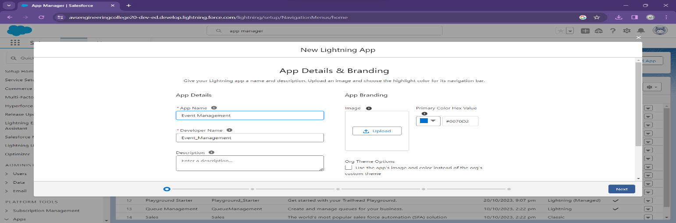

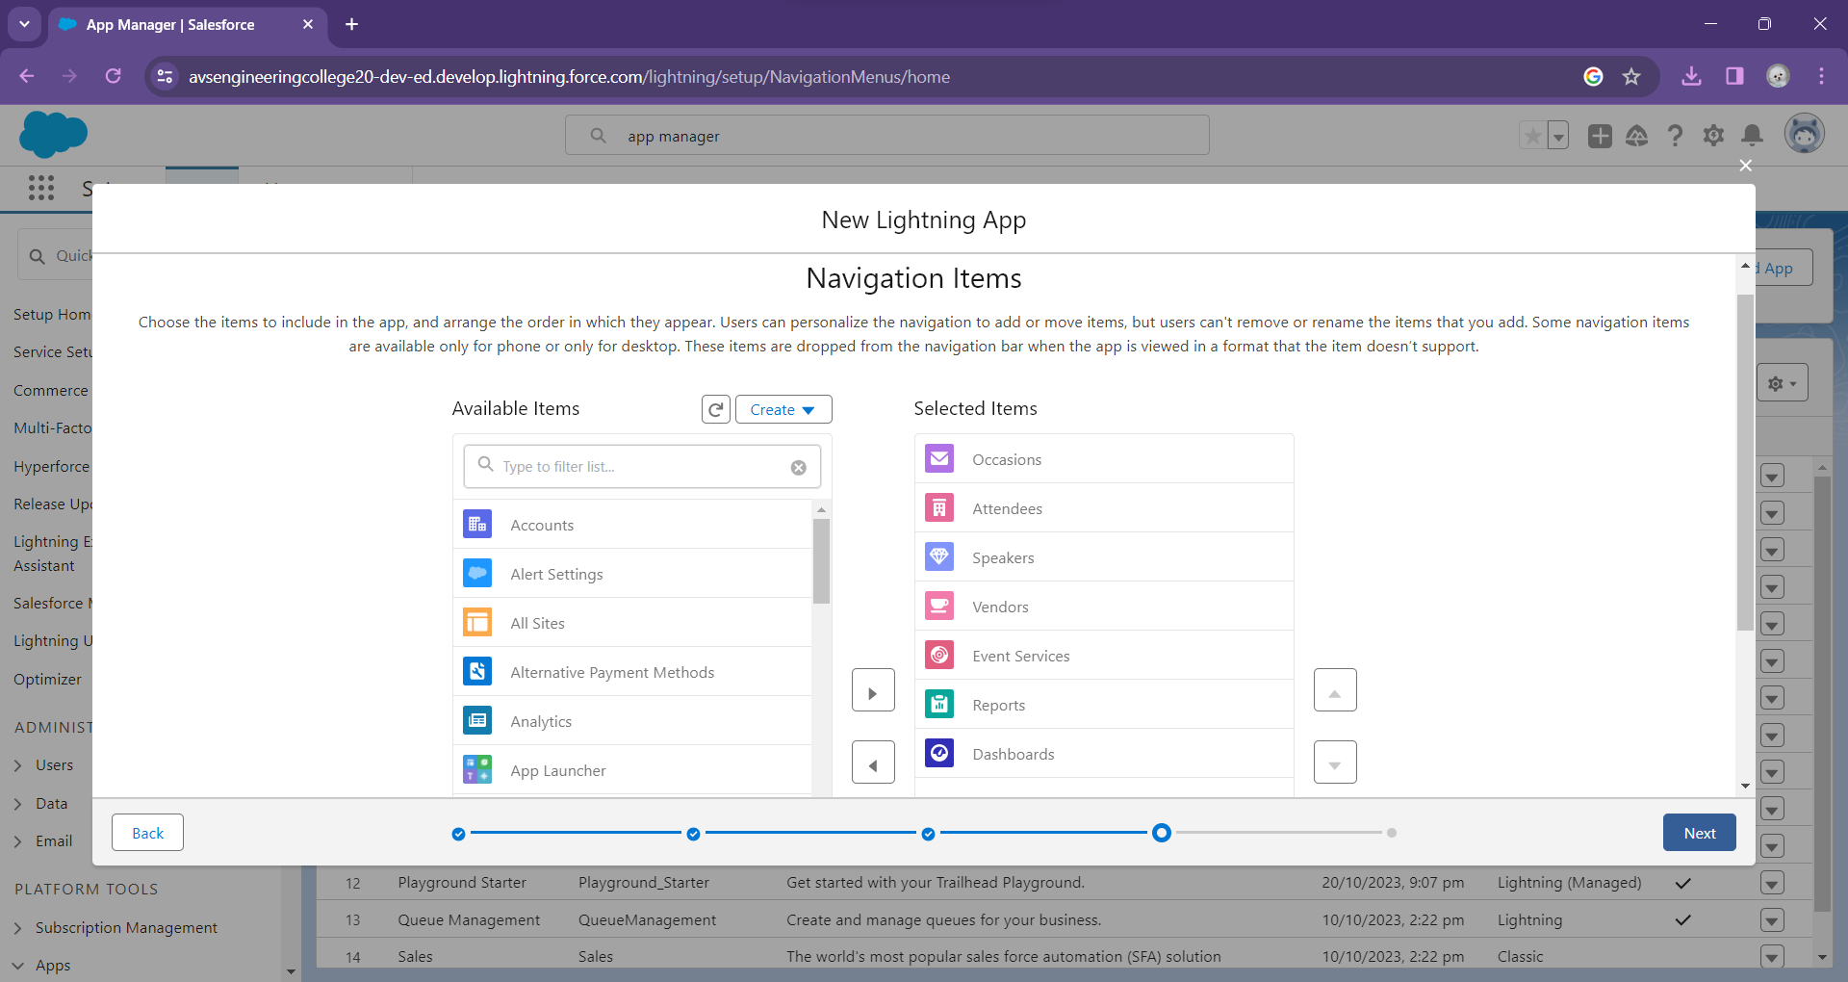

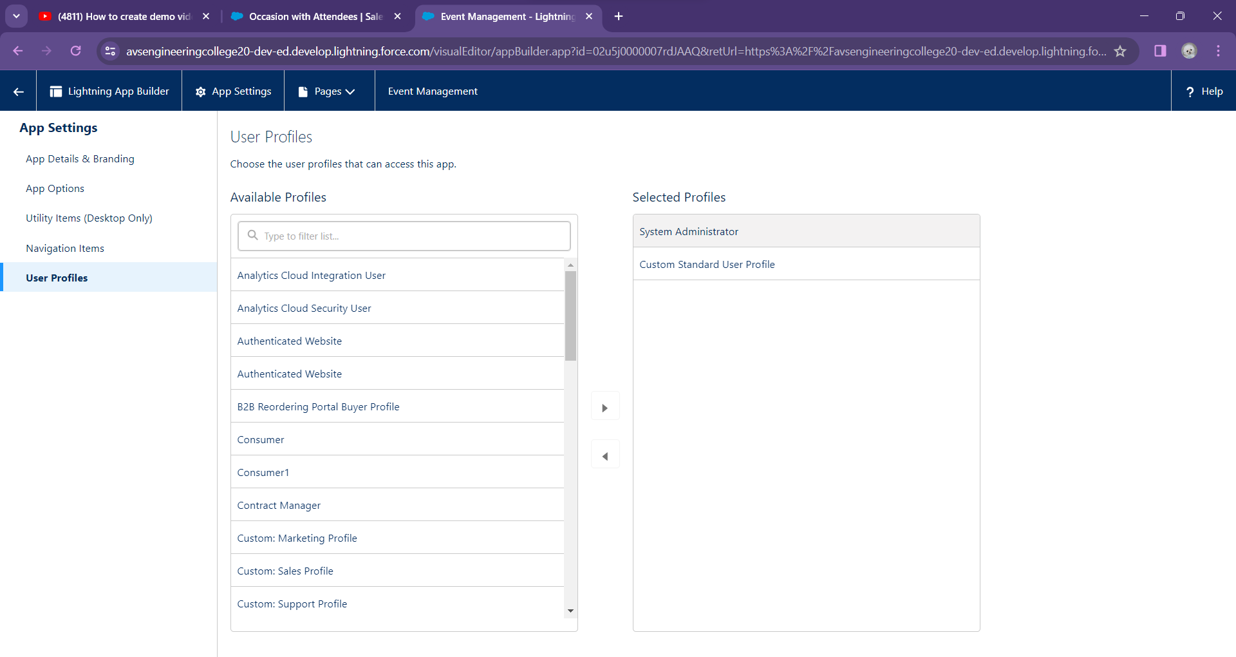

**CHAPTER 3**

**USERS AND DATA SECURITY**

**3.1 USER**

Before customizing the event management app, first create a new user, Sanjay gupta Executive, and set him up as manager. This involves assigning roles and profiles so that Sanjay has the correct permissions to approve event requests.

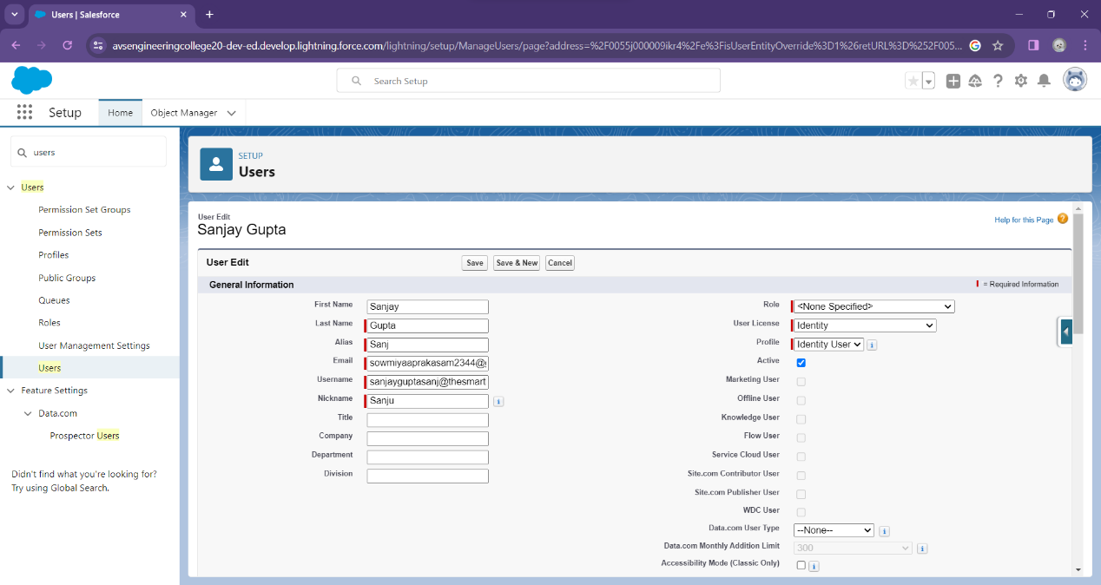

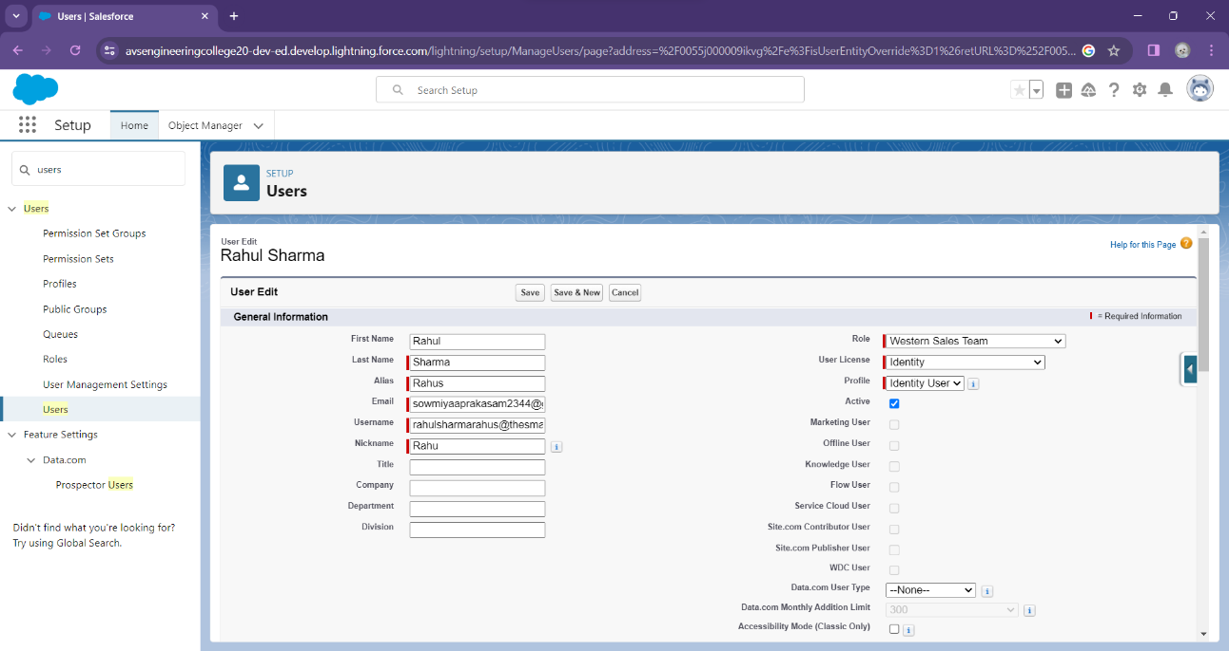

**3.2 PERMISSION SETS**

On this page you can create, view, and manage permission sets.

**CREATION OF EVENT PERMIT:**

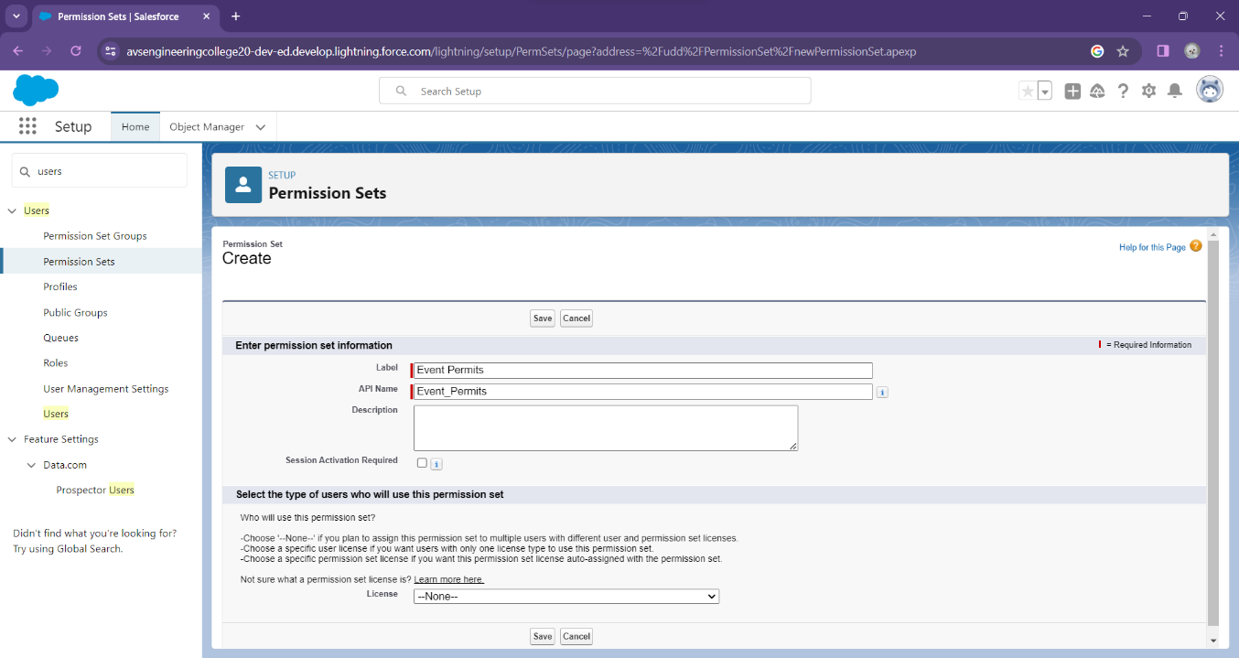

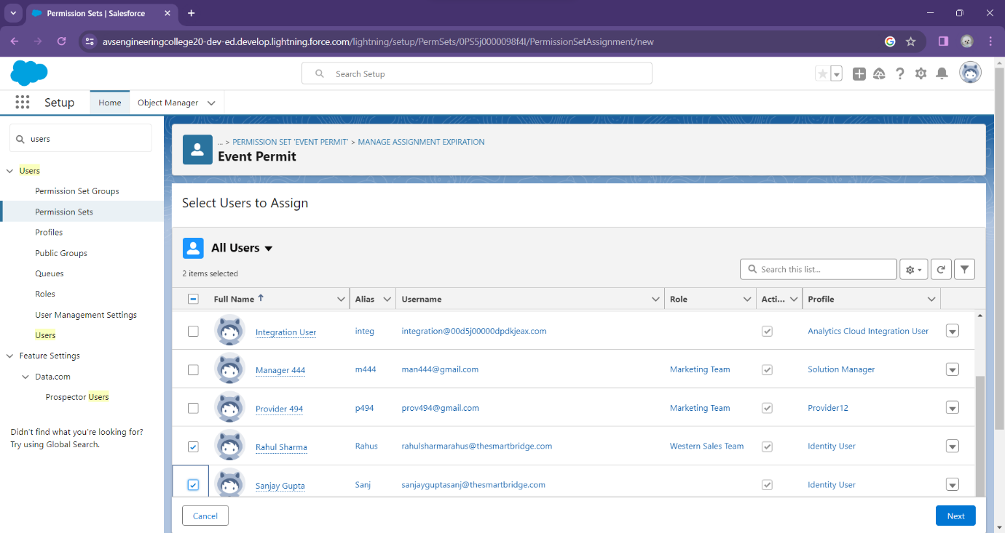

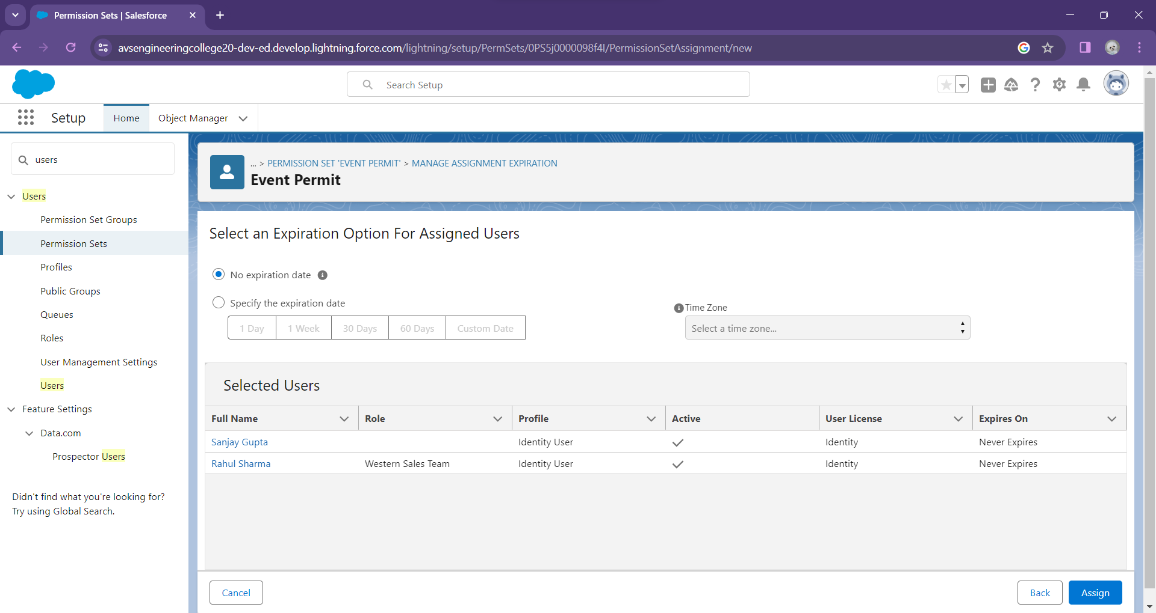

**CREATION OF VENDOR PERMIT:**

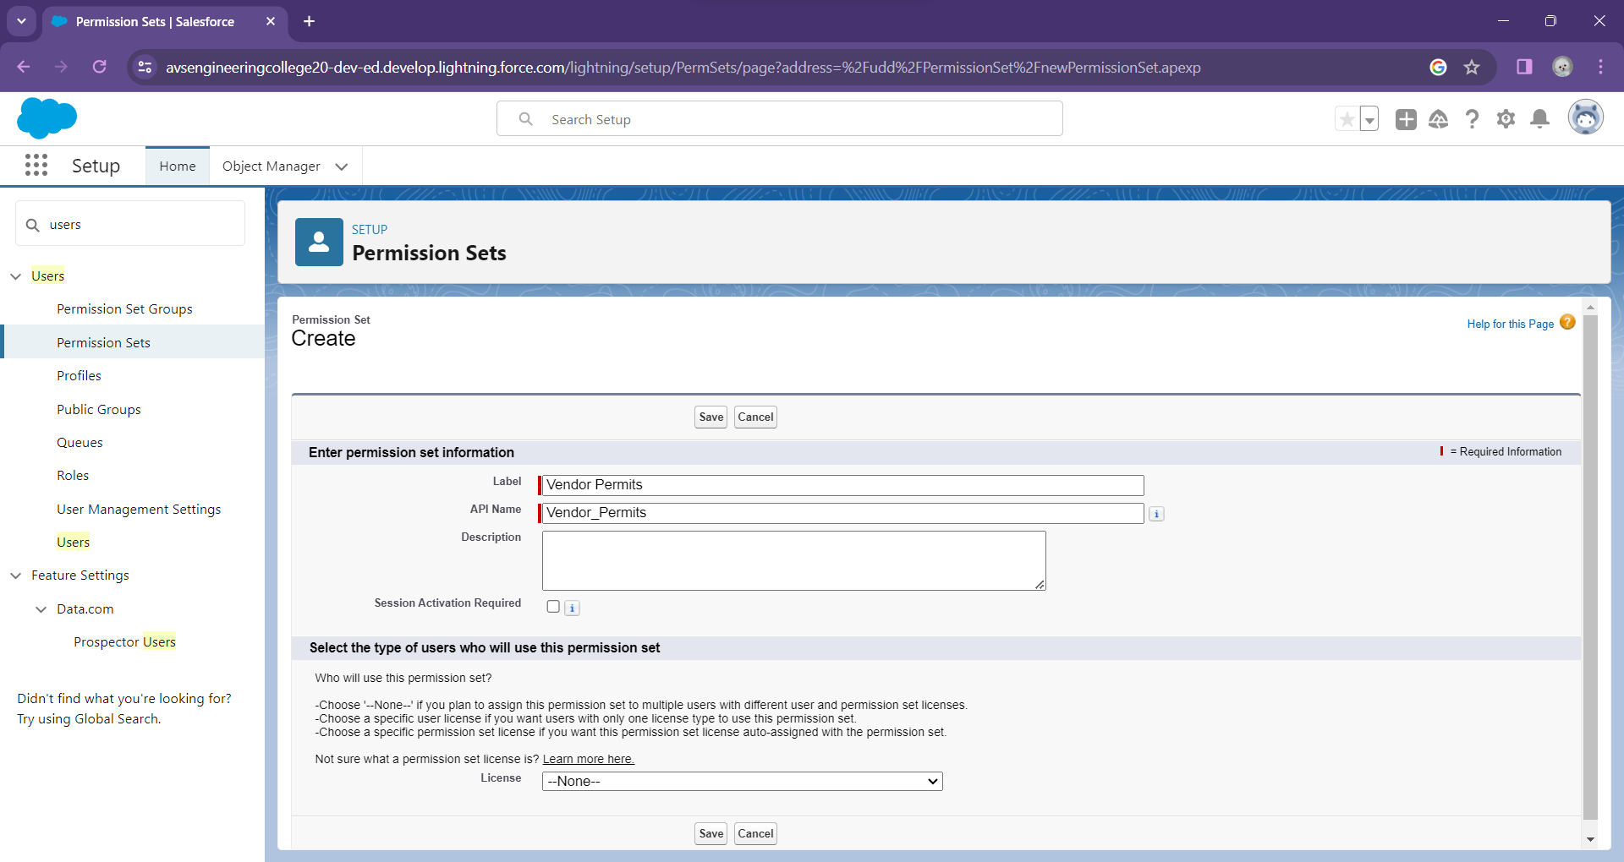

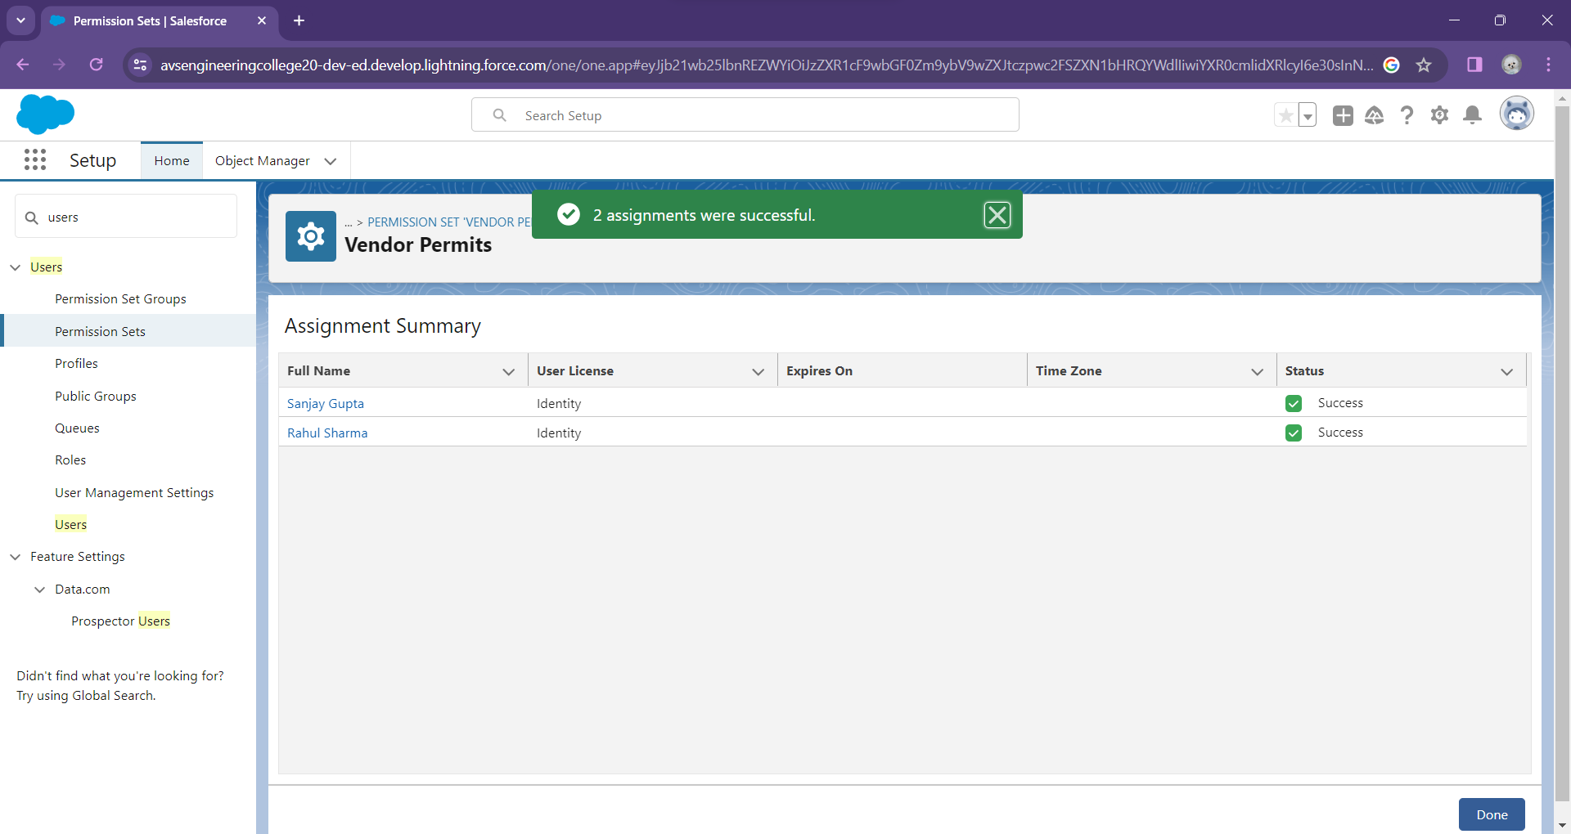

**3.3 PROFILE**

A profile is a group/collection of settings and permissions that define what a user can do in salesforce. A profile controls “Object permissions, Field permissions, User permissions, Tab settings, App settings, Apex class access, Visualforce page access, Page layouts, Record Types, Login hours & Login IP ranges.

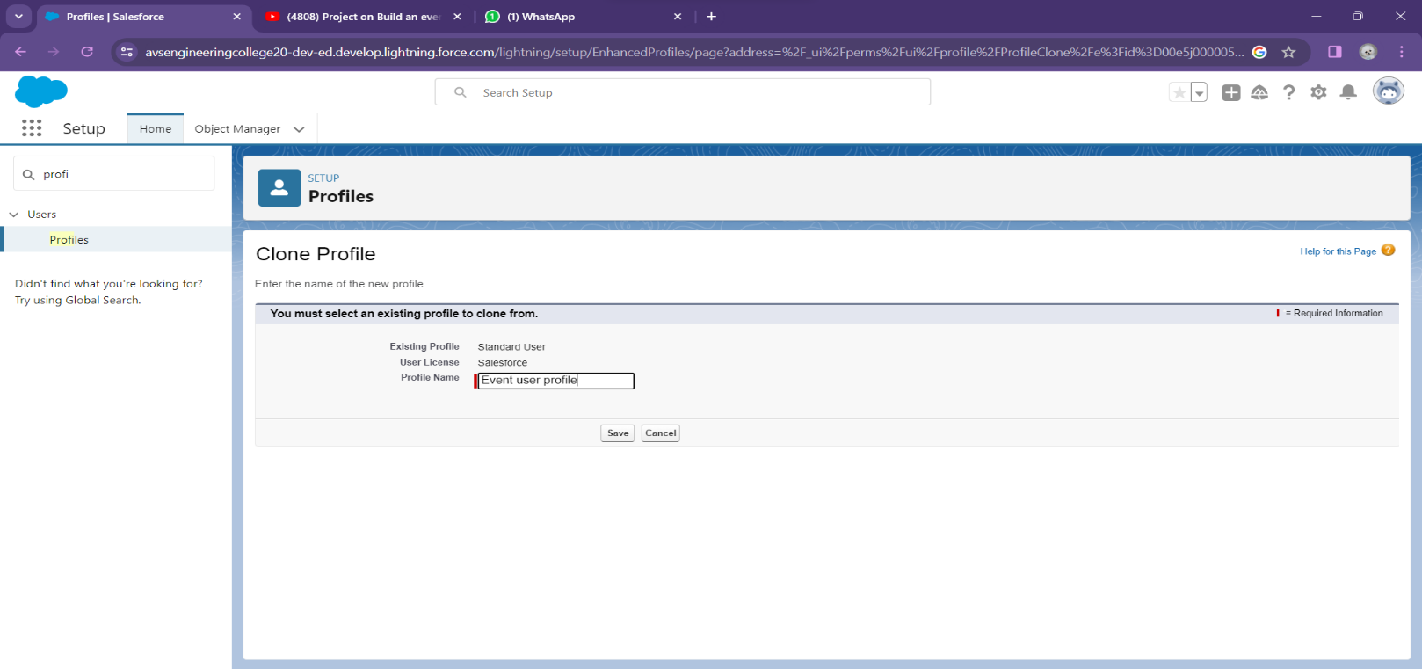

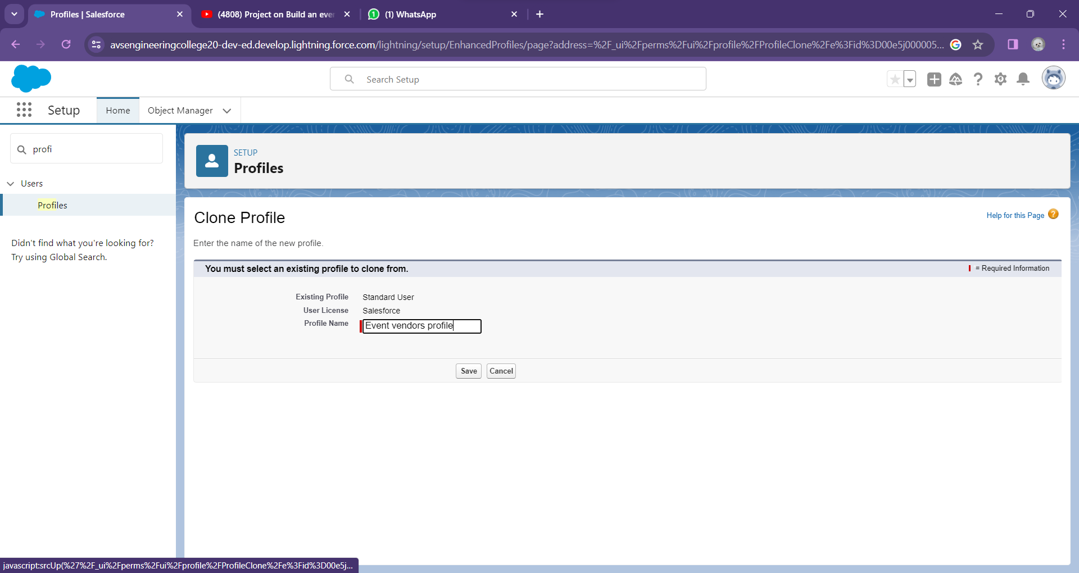

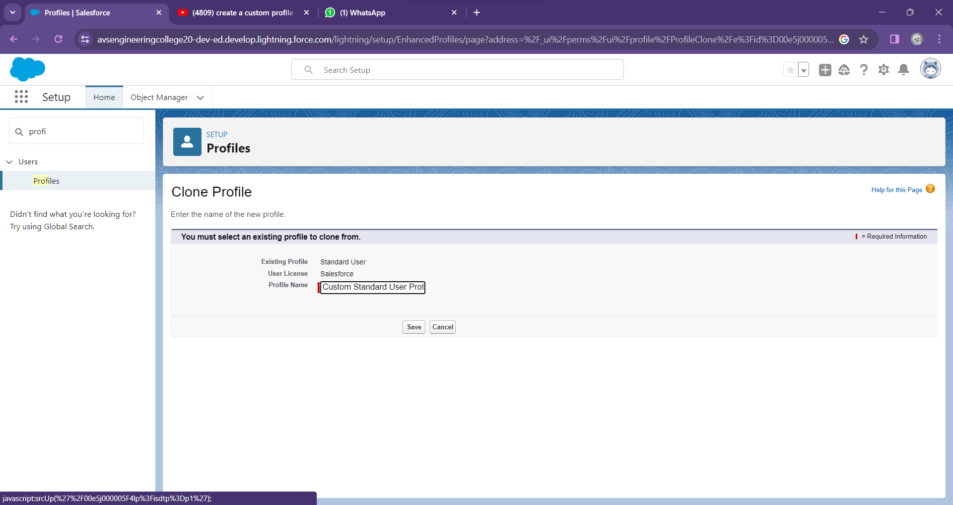

**CHAPTER-4**

## AUTOMATION

**4.1 APPROVAL PROCESS**

The approval process in Salesforce is a powerful tool that allows you to automate and streamline the approval of records such as opportunities, leads, cases, and custom objects. It is a workflow process that is triggered when a record meets certain criteria and requires approval from one or more approvers before it can be moved forward in the sales process.

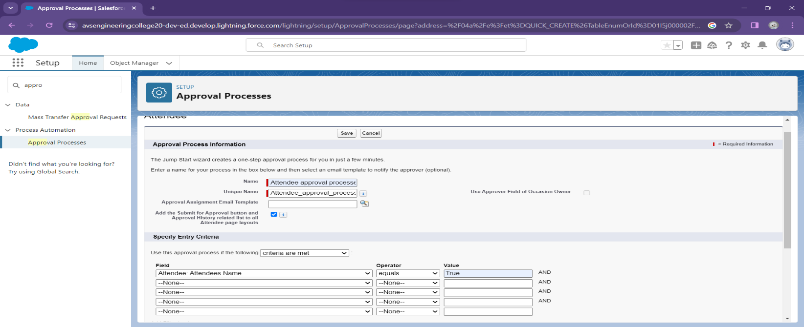

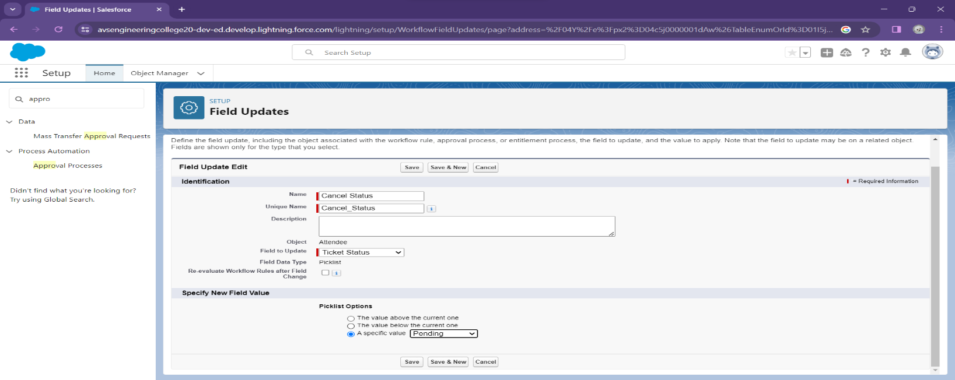

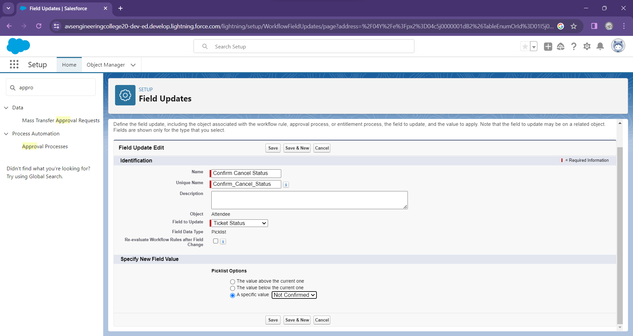

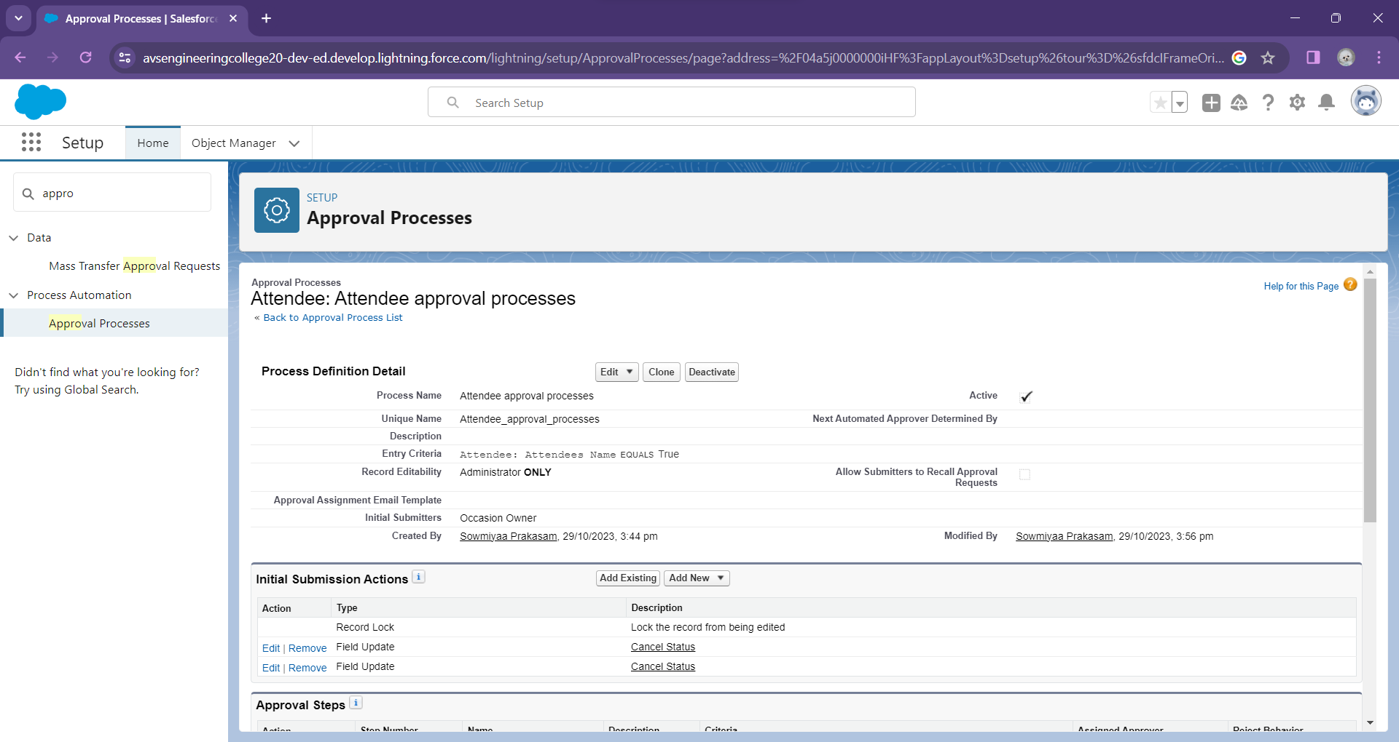

**CHAPTER-5**

## REPORTS & DASHBOARD

### **5.1 Reports**

A Salesforce report is a list of data generated based on filter criteria. Salesforce Reports helped us predict trends and gives us the advantage to increase profits.

The report builder provides a drag-and-drop interface to easily build and customize your reports.

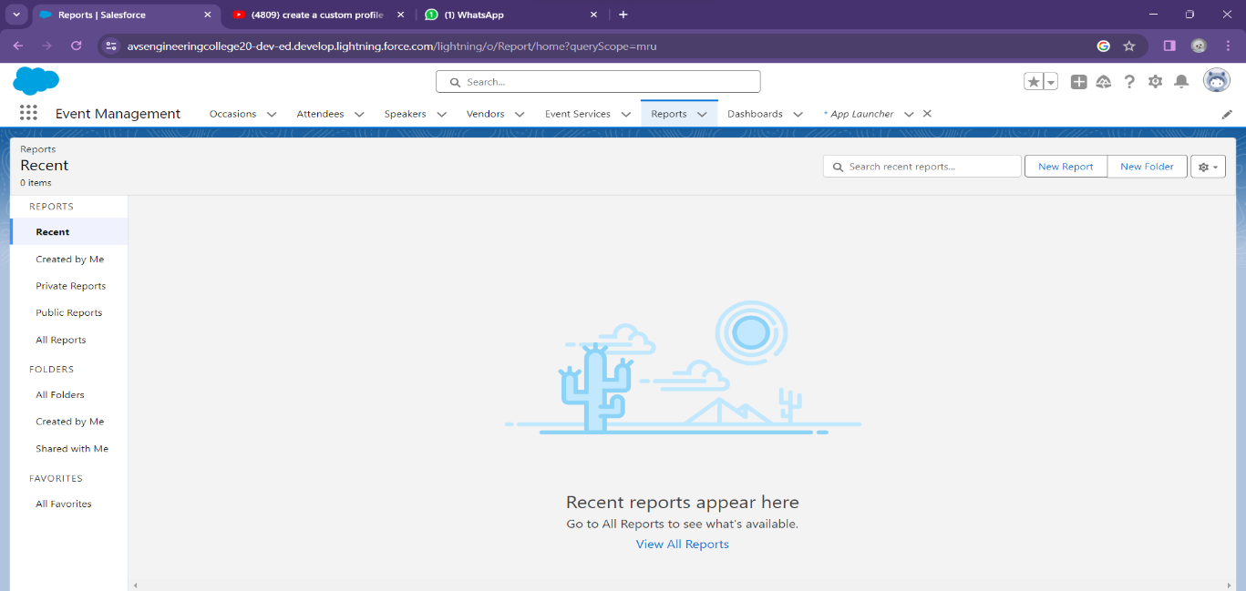

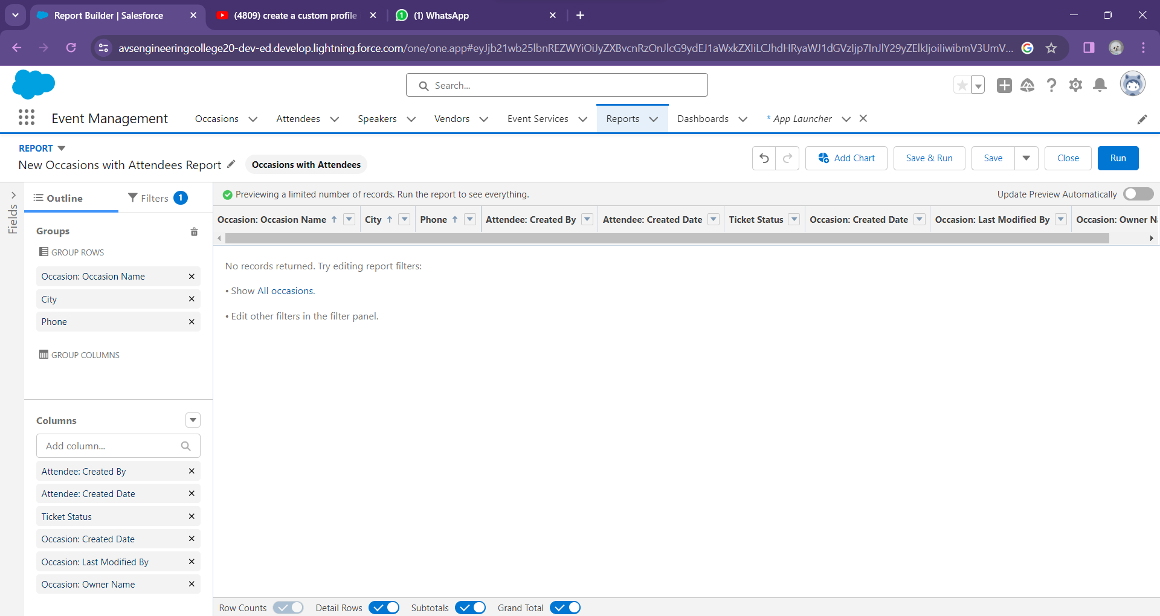

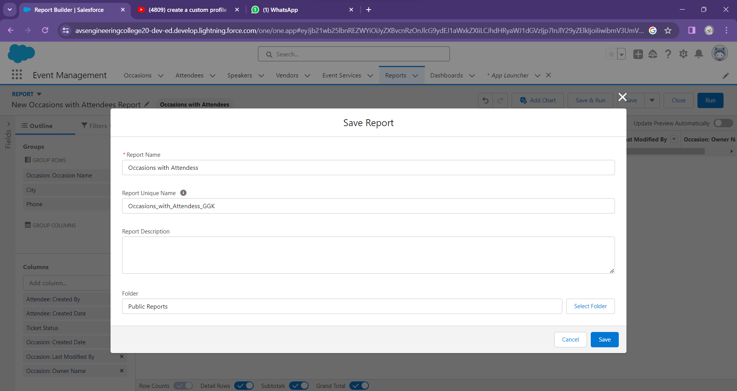

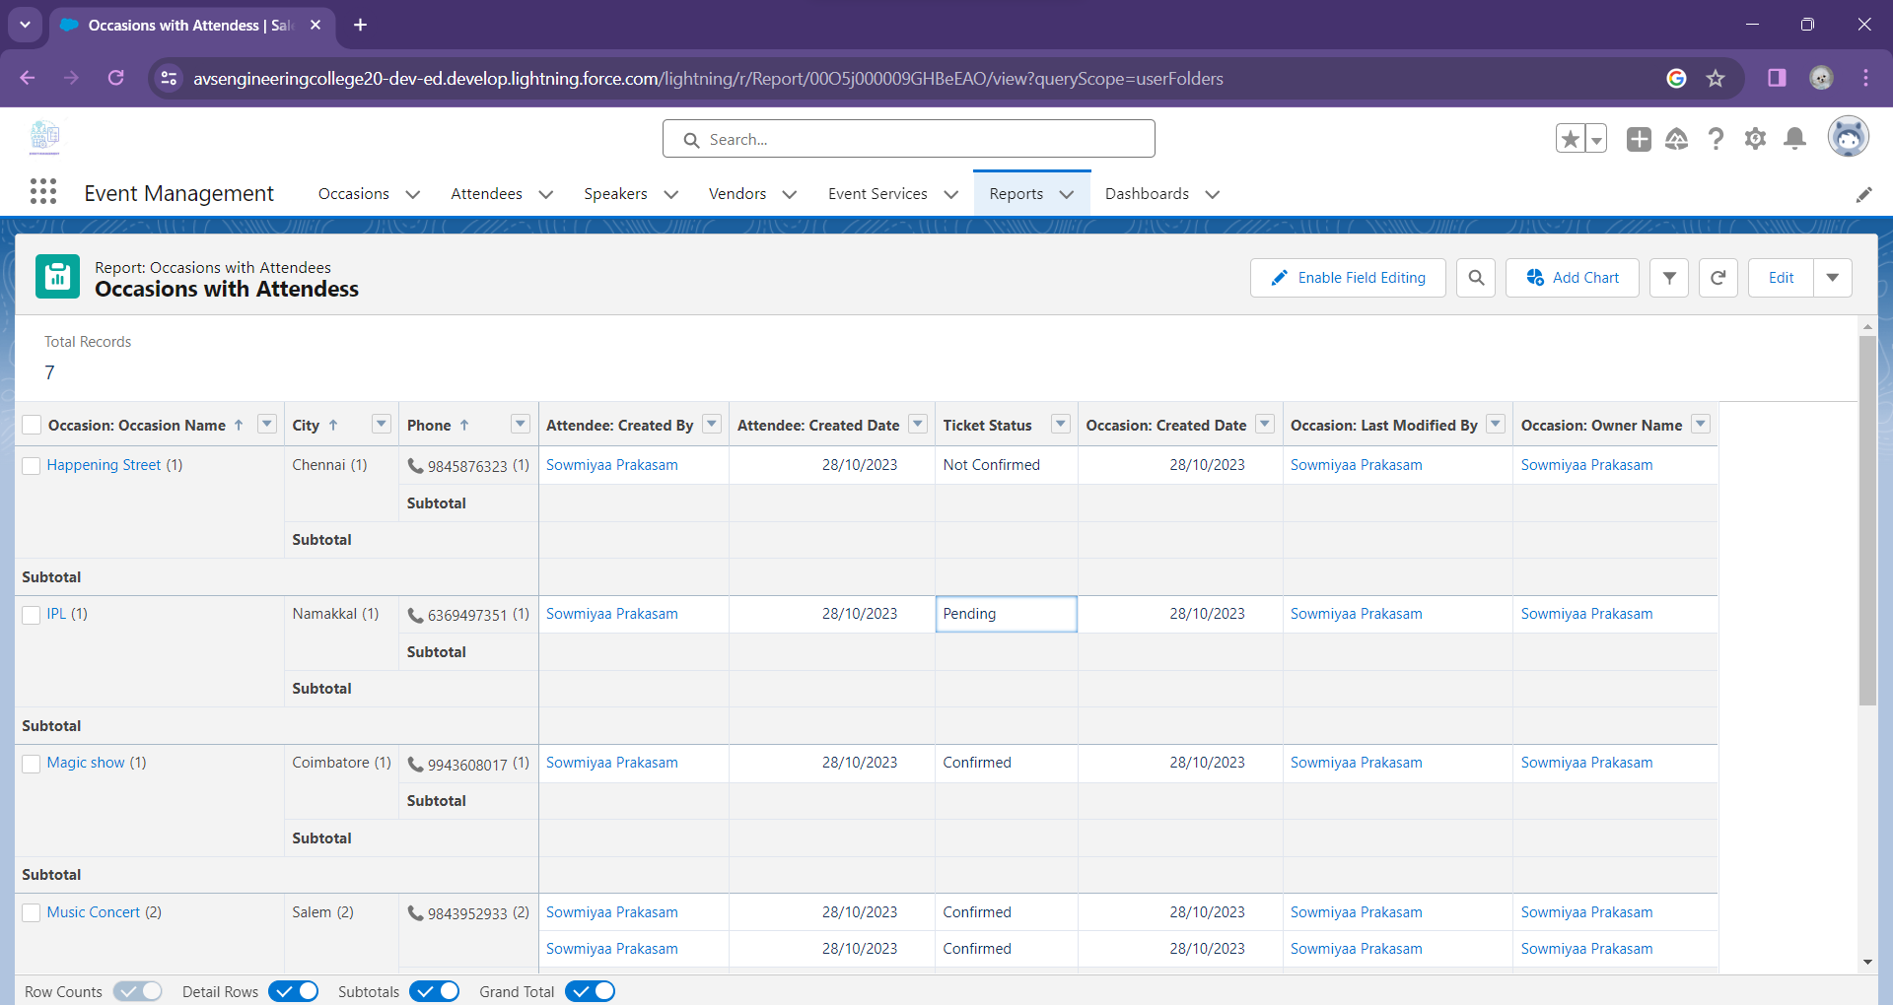

### **5.2 Dashboard**

A dashboard provides an interactive visual display of key metrics and trends. Multiple dashboard components can be shown together on a single dashboard layout, creating rich visual displays of multiple reports that have a common theme.

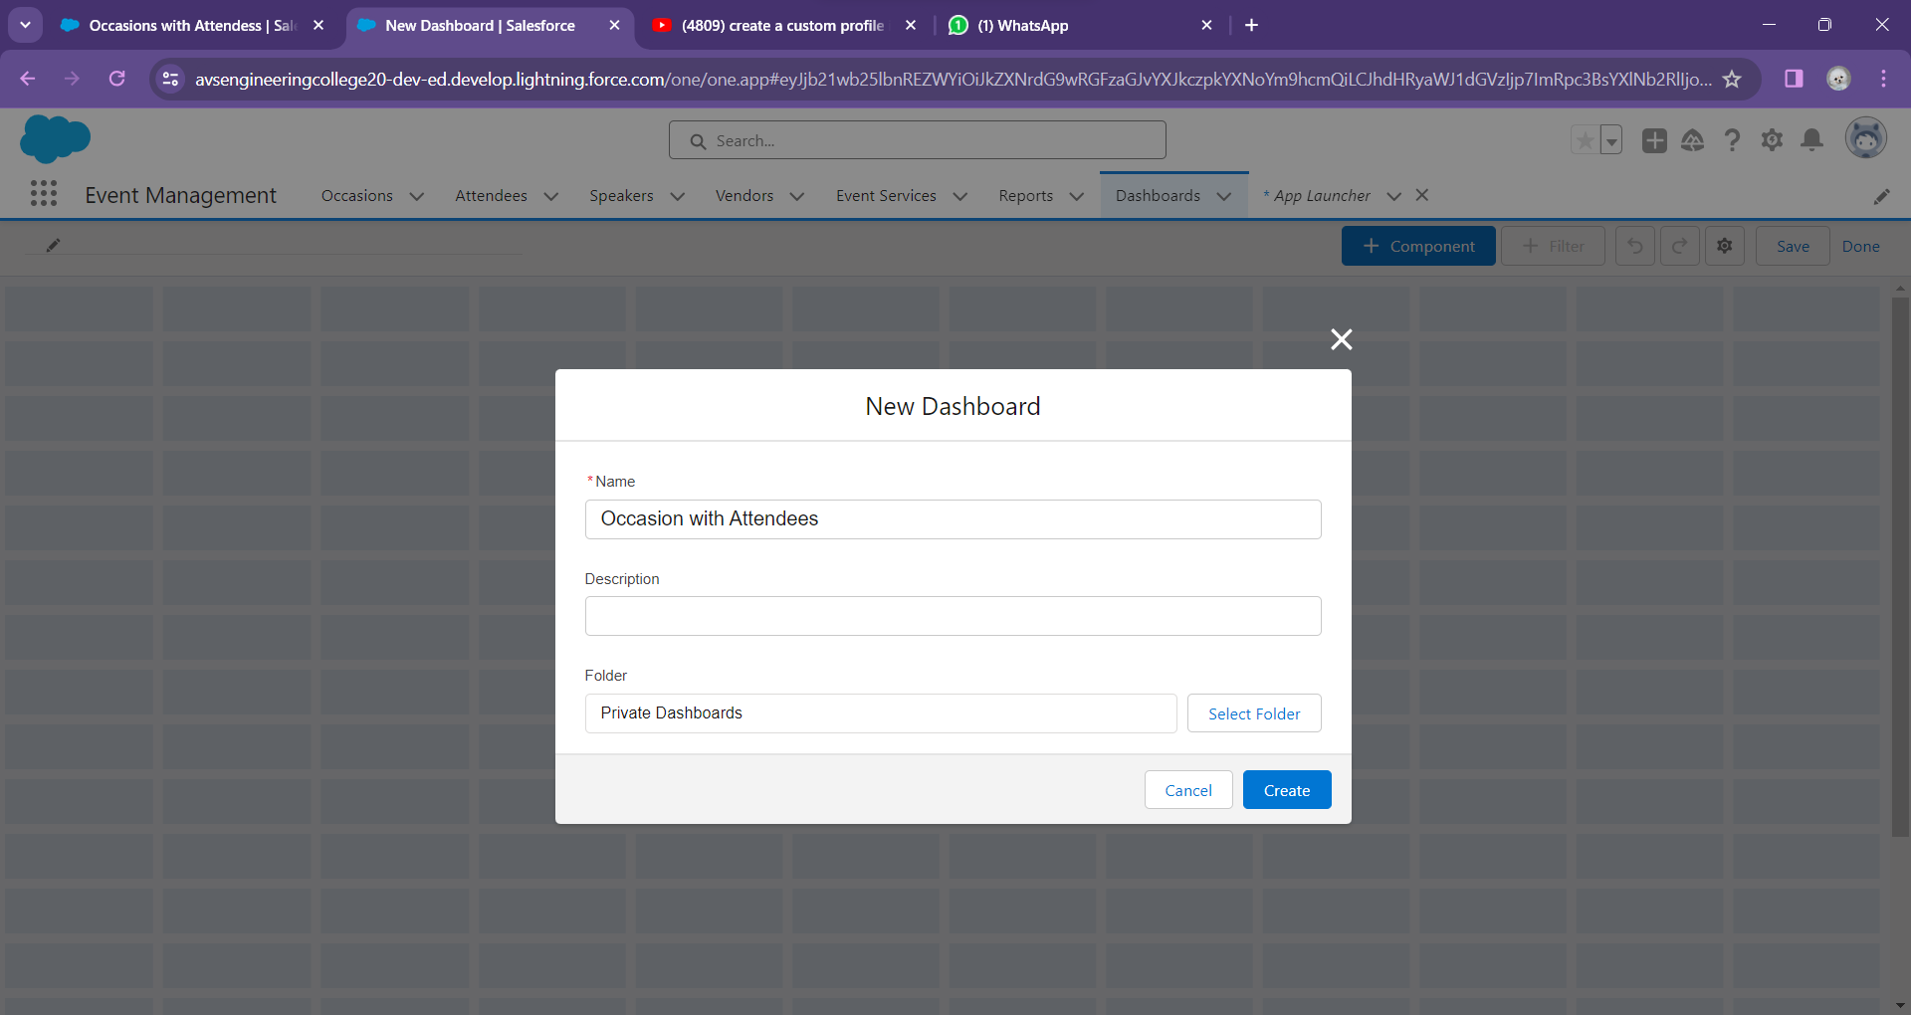

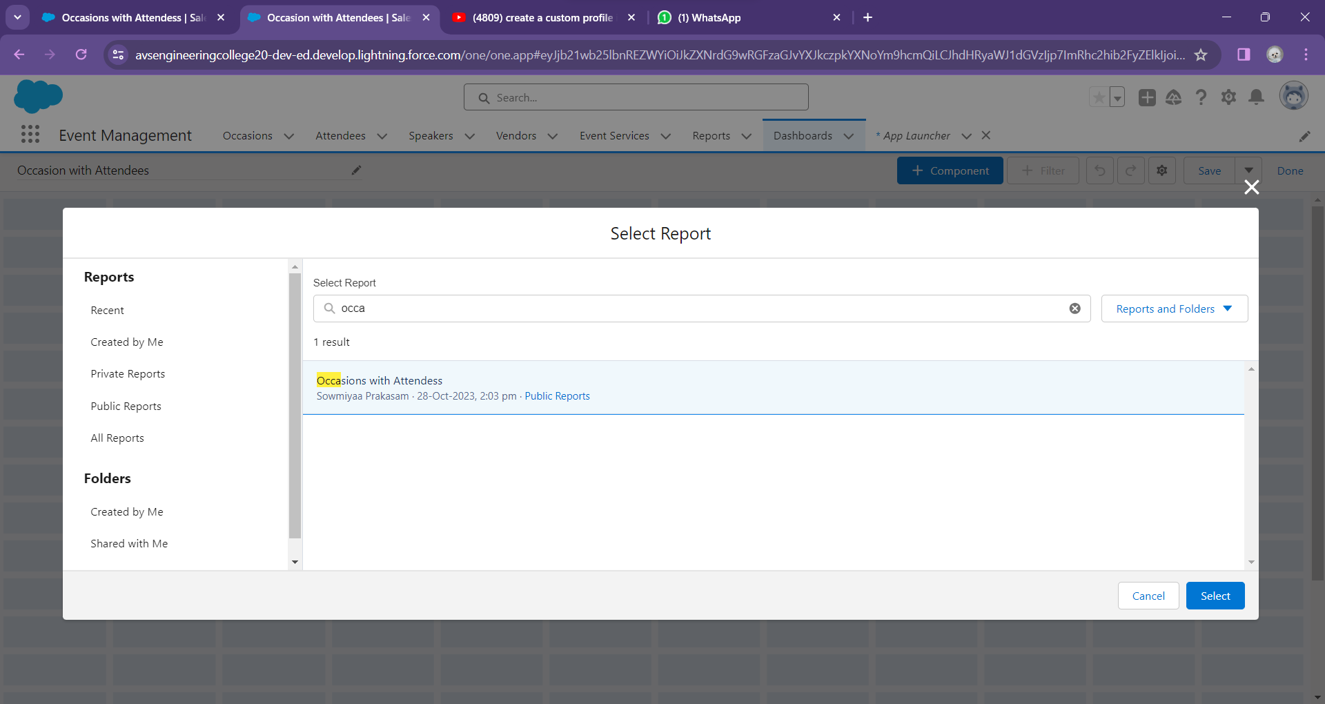

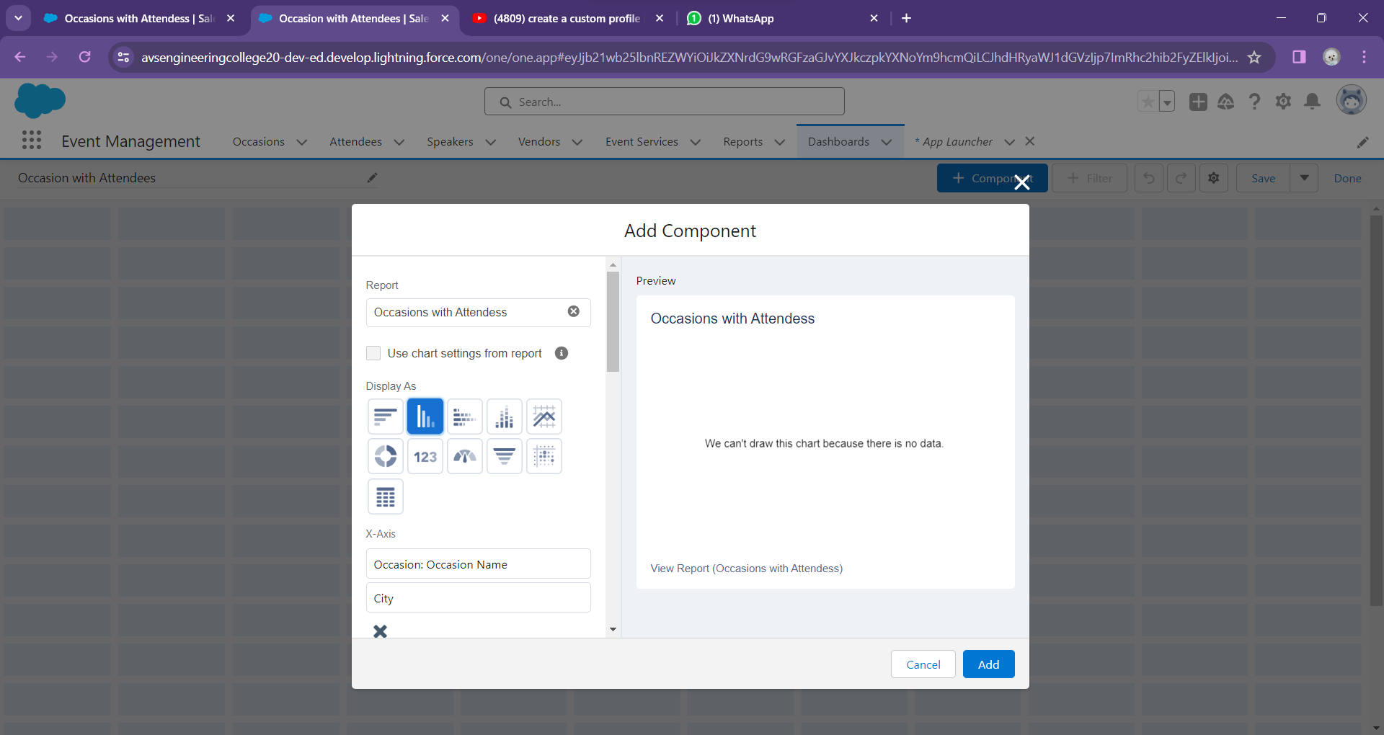

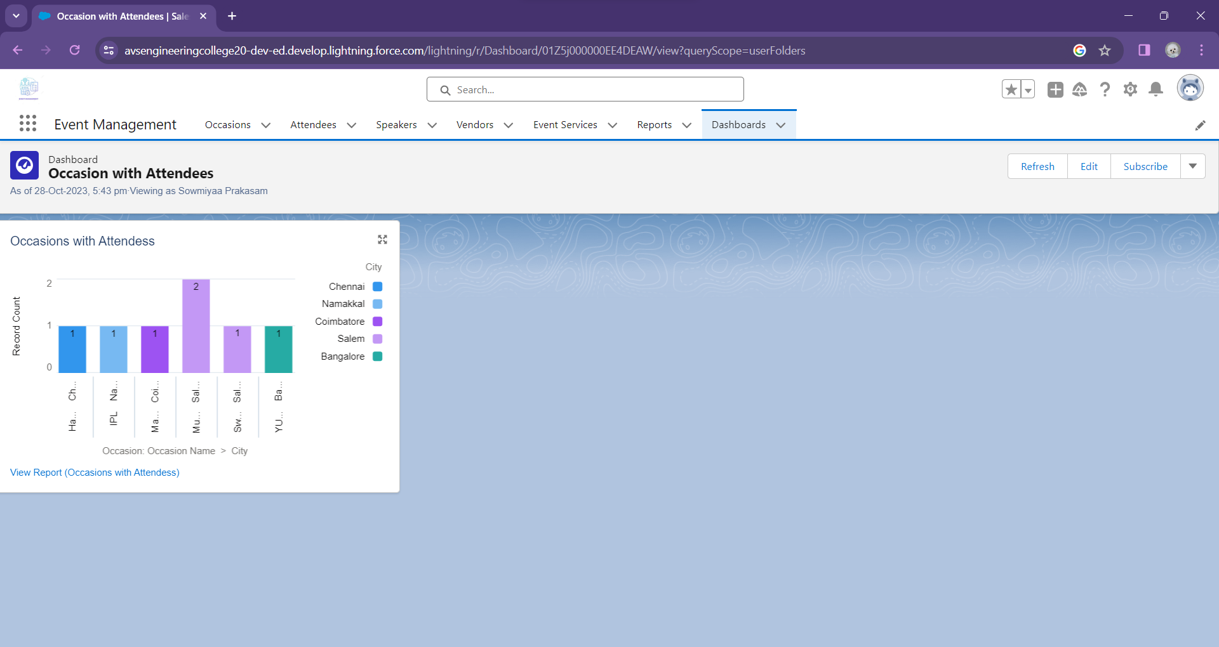

**5.3 USER ADOPTION**

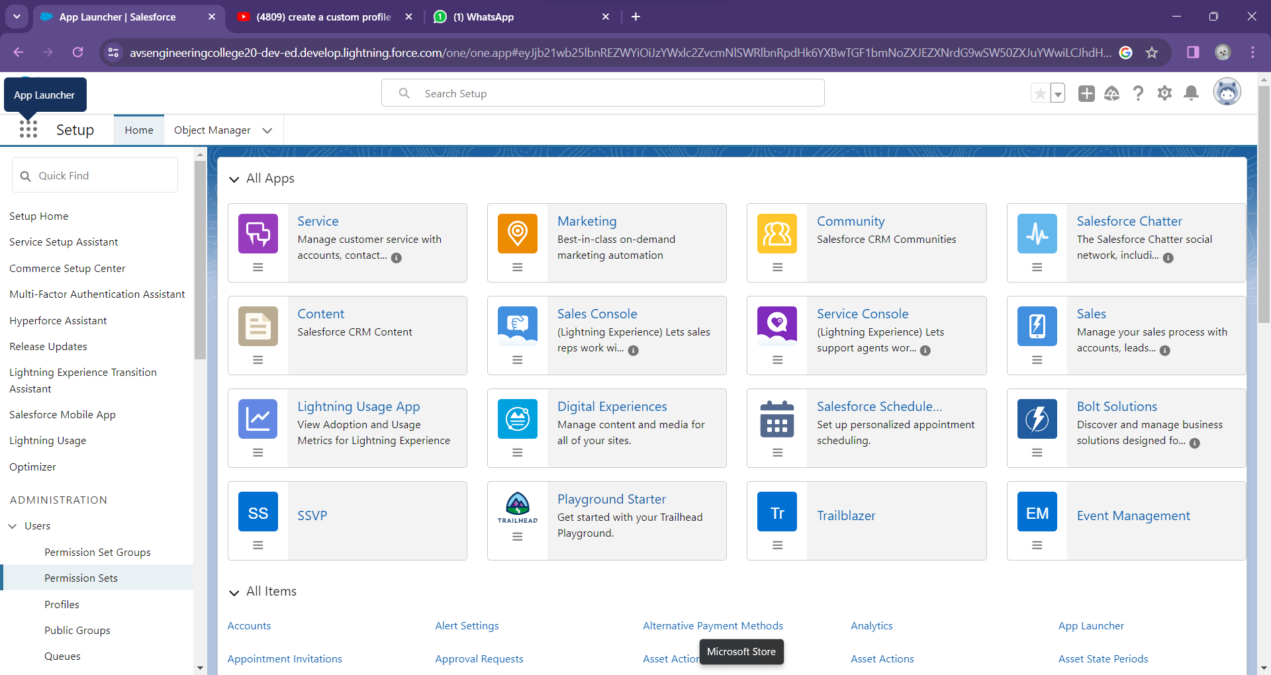

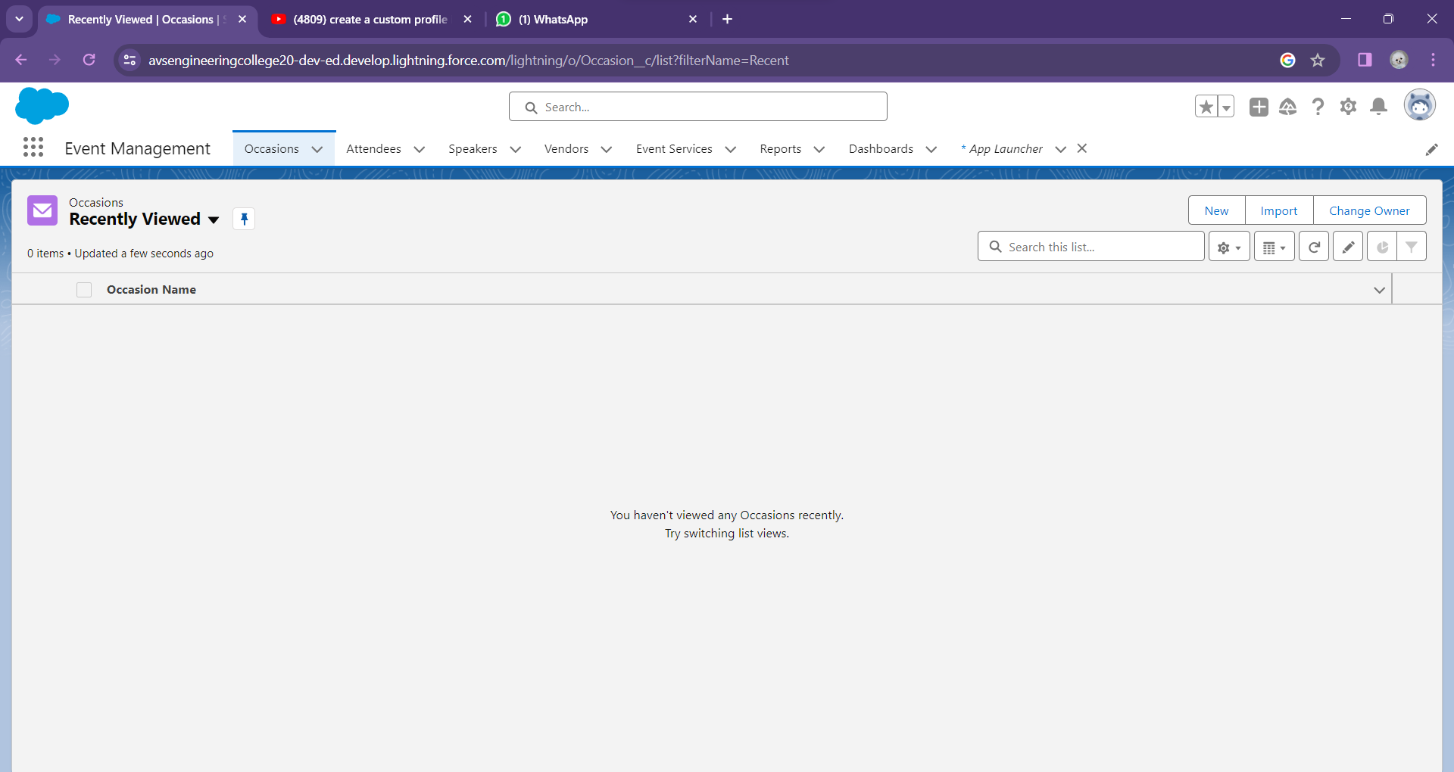

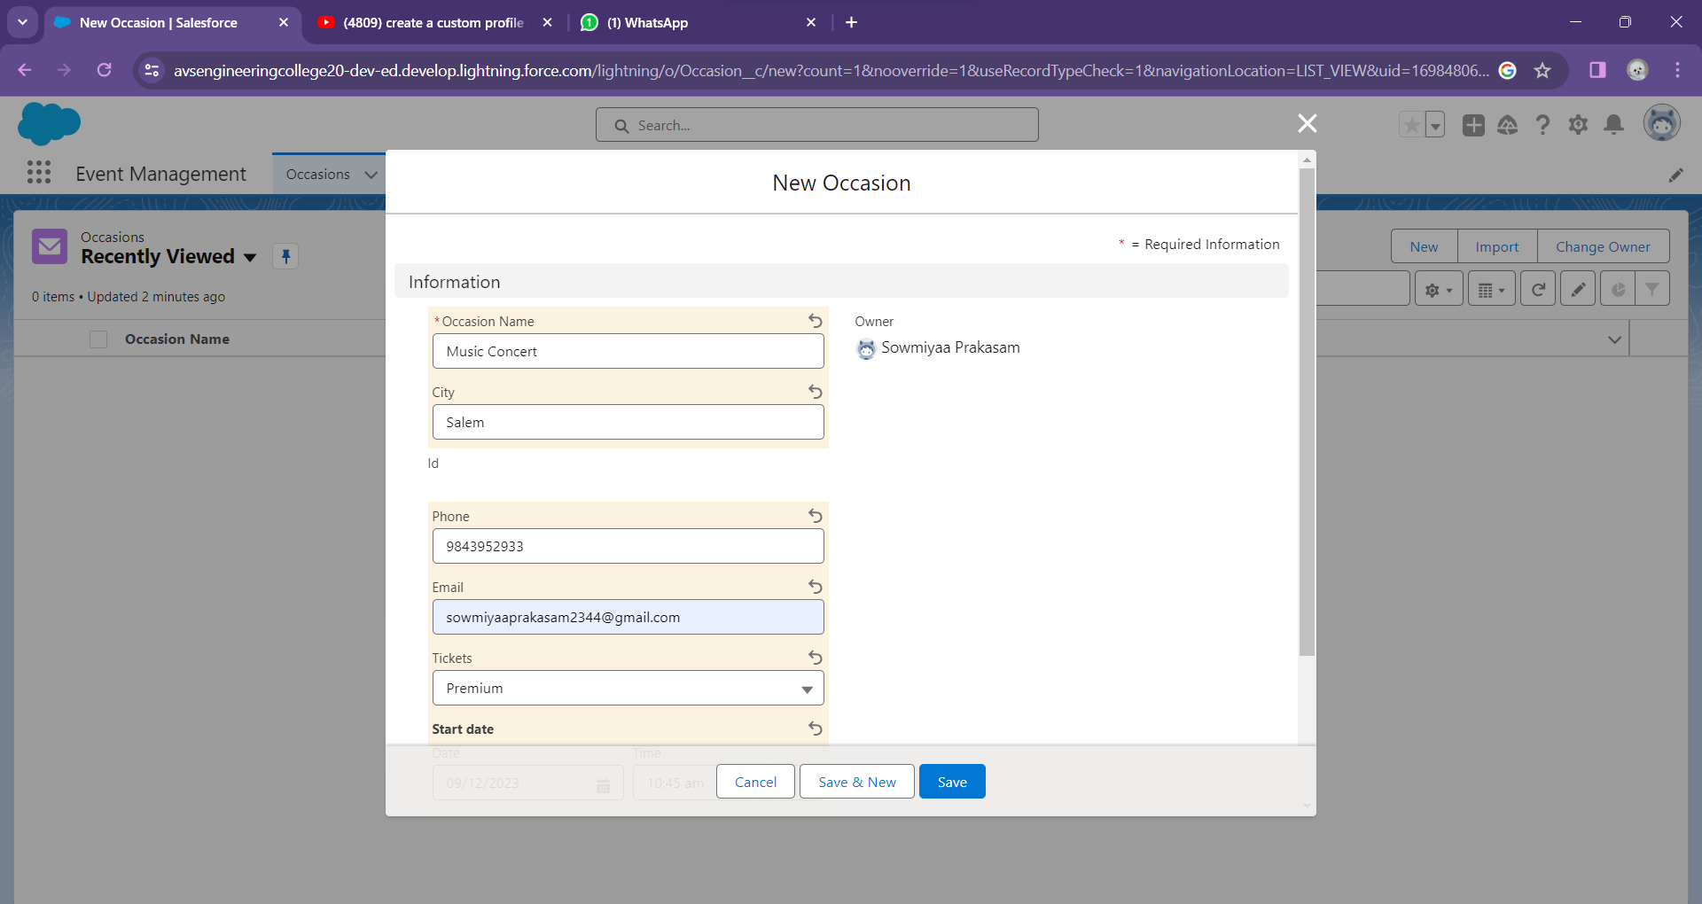

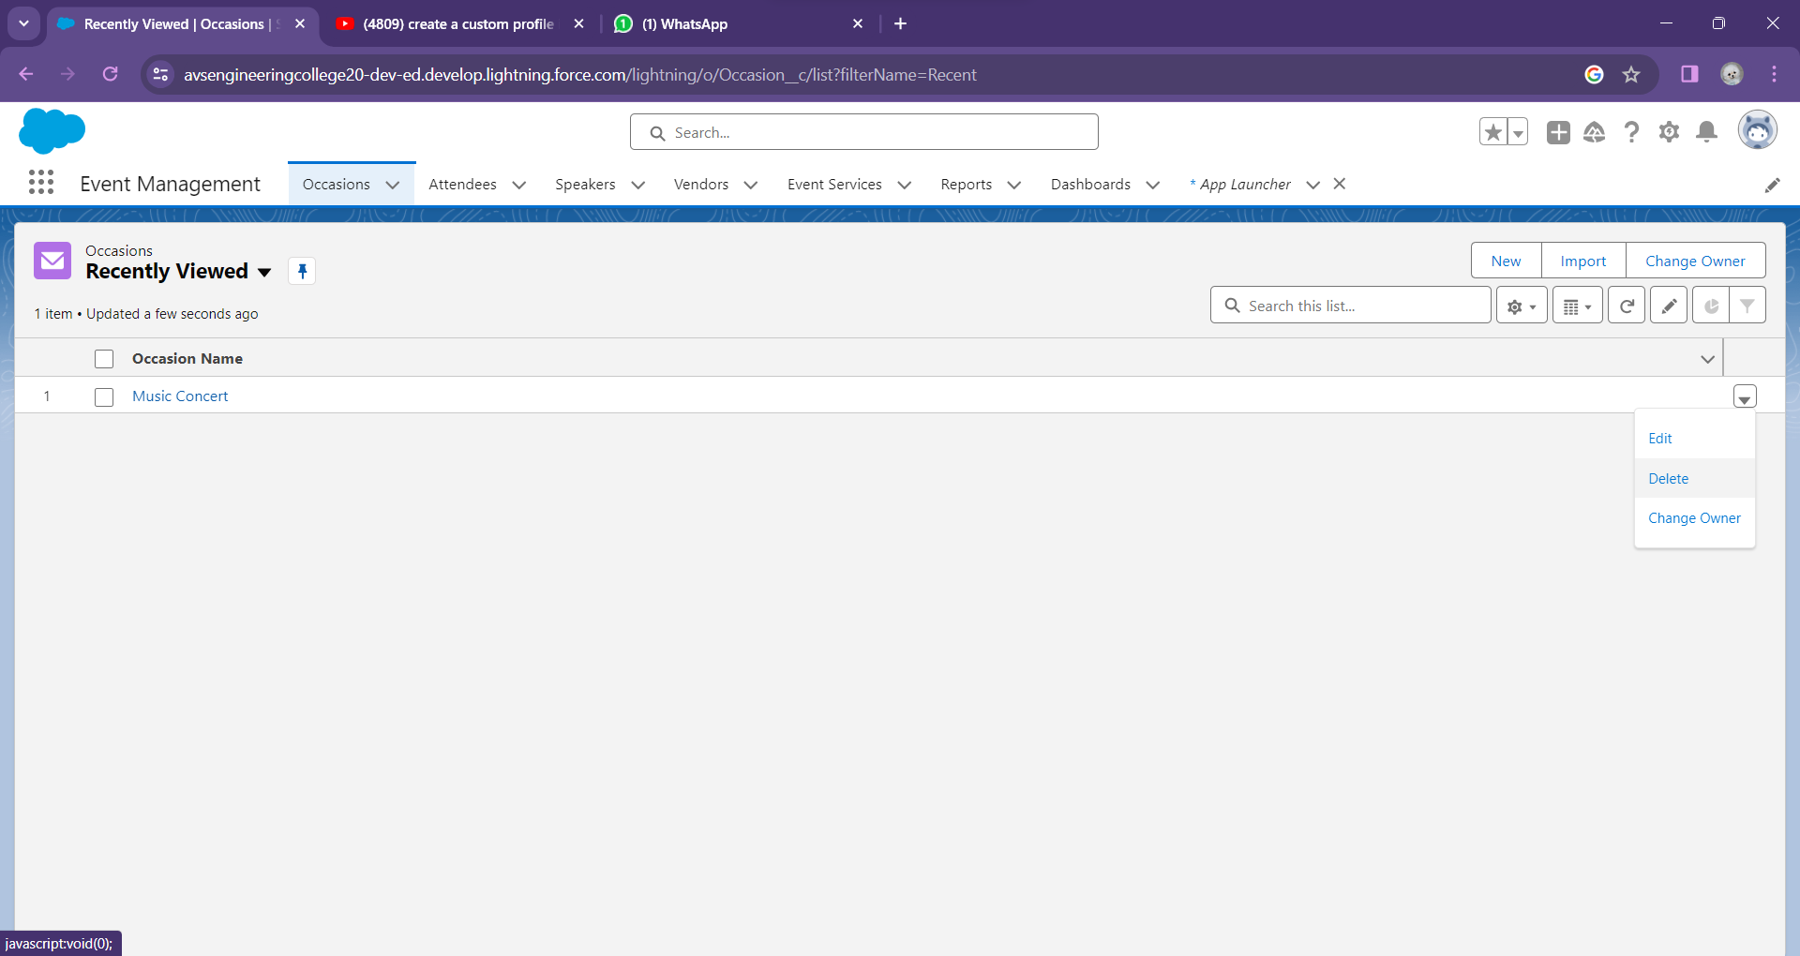

**CONCLUSION**

In conclusion, the development of an Event Management System (EMS) represents an opportunity to transform the way we plan, execute, and experience events. The challenges outlined in the initial problem statement underscore the need for a comprehensive solution that not only streamlines event management but also enhances participant satisfaction and fosters a sense of community. Through innovative features and functionalities, such as AI-powered recommendations, blockchain ticketing, and sustainability initiatives, an EMS can set new standards in the industry.

Furthermore, the system's technical and functional requirements, ranging from security and scalability to data analytics and accessibility, are crucial in delivering a robust and reliable platform. By adhering to these requirements, we can ensure that the EMS meets the highest standards in terms of performance, data privacy, and user accessibility.

In an era where events play a vital role in professional and social life, the creation of an EMS opens the door to efficient, engaging, and sustainable event management. It empowers organizers to make data-driven decisions, provides a personalized experience for attendees, and contributes to a more connected and eco-conscious event ecosystem. Ultimately, the successful development and implementation of this system promise to revolutionize the event management landscape, leaving a lasting positive impact on organizers, participants, and the environment alike.

**CHAPTER-7**

## PROJECT DEMONSTRATION

**Github:**

[**https://github.com/Sowmiyaa-Prakasam/NAAN-MUDHALVAN**](ChromeSetup.exe)

**Demo Link:**

**<https://youtu.be/vasbrxmsDco>**

**TRAILHEAD LINKS:**

**SOWMIYAA P:**

[**https://www.salesforce.com/trailblazer/sowmiyaaprakasam**](https://www.salesforce.com/trailblazer/sowmiyaaprakasam)

**SOWNDARYA S:**

[**https://www.salesforce.com/trailblazer/sowndharyas3170**](https://www.salesforce.com/trailblazer/sowndharyas3170)

**PRIYADHARSHINI R:**

[**https://www.salesforce.com/trailblazer/priyadharshinirziftao2auyun**](%20https:/www.salesforce.com/trailblazer/priyadharshinirziftao2auyun)

**SRI SETHA DEVI M:**

[**https://www.salesforce.com/trailblazer/sriswethadevim**](https://www.salesforce.com/trailblazer/sriswethadevim)

**VIDHYA SRI R:**

**[https://www.salesforce.com/trailblazer/vidhyasriraja]( https://www.salesforce.com/trailblazer/vidhyasriraja)**